**St Catherine’s Primary School **

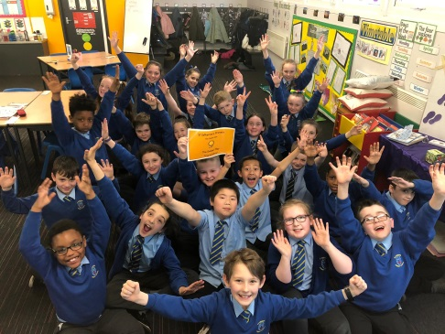

**June Newsletter**

Dear Parents/Carers,

I can’t believe we are into our last month of this school year. It is a busy month in St Catherine’s! Please take a note of the dates below there is a lot going on in our school this month

**Dates for your Diary**

*If parents and carers are invited along to a school event, it will state ‘Parents invited’ next to the event.*

***JUNE***

***3rd – 5th - P7s away to Ardmay House – Residential Trip***

***3rd – 7th - Rookie Rockstars in school working with the children***

***6th - Family Fun Night –Everyone Invited - 5.00pm – 6.30pm***

***Come along and see what our partner agencies can offer your family and have some fun and freebies!***

***7th - Induction Day 2 for our new P1 children in August – Parents Invited***

***10th - P1 & P2 trip to Almond Valley***

***11th - P4 – P7 children visit from author***

***12TH - Rookie Rockstars Show – 6.30pm - Parents Invited***

***13th - P3 & P4 trip to Almond Valley***

***13th - Cluster Schools Football Event***

***19th - P7 Leaver Mass, Graduation and Prom – more info to follow – Parents Invited***

***21st - P7 trip to Flip Out***

***24th - Upper Sports Day – more info to follow – Parents Invited***

***25th - Infant Sports Day – more info to follow – Parents Invited***

***28th - Last day of term school closes at 1.00p***

***Safety of our children***  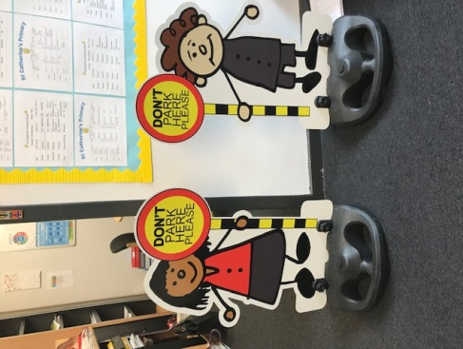

Can I please remind all parents/ carers **Please do not park on the Zig Zags outside the school.**

Recently got to borrow parking buddies from the Road Safety team at Glasgow City Council. We have had some very positive feedback from parents and we could see the impact they made in keeping children safe.

**Can I also remind you that all parents and carers must only enter the school building through the front door and report in to the reception. This is to comply with our Child Protection Policy.**

***Church Events ***

We were so proud of our P4 children who made their First Holy Communion in May. It was a lovely day and it was great seeing so many our St Catherine’s children celebrating this important sacrament. The children all looked wonderful and it was a very special occasion. A huge thanks goes to Father Gallagher, all the catechists and members of the parish that helped to make it such a special day.

***What’s been happening last month?*** 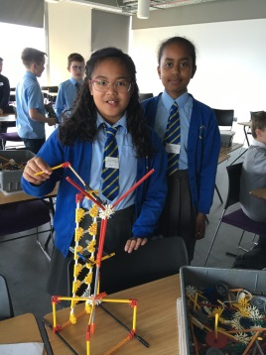

It’s been a busy month for us at St Catherine’s the boys and girls have been out and about enjoying new learning experiences. As well as being out of school we enjoyed a great visit from RSPB to learn more about sustainability.

P2/1 visited the Science Centre.

2 P6 children went to the City of Glasgow College to represent our area in the KNex Final.

P5 classes went to Belfast to visit the Titanic Experience. Many members of the public commented on their wonderful behaviour and manners.

P5 also took part in the Go Yellow Walk in Bellahouston PArk

***Family Learning***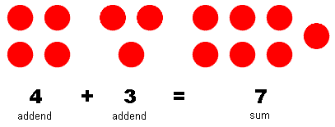

Ms Devlin held the three of four sessions on helping your child with aspects of Maths. We had a great turnout for the addition, subtraction and multiplication sessions.

***HMIe Inspection ***

Thank you to everyone that supported our work during our recent HMIe inspection. We really appreciate those of you who took the time to complete questionnaires and meet with the inspectors. We look forward to sharing with you the results of the inspection in due course.

*If you wish to contact me about anything in this newsletter please don’t hesitate to get in touch.*

*Best Wishes*,

*[](http://www.ywcacassclay.org/)Michelle Wright*

*Headteacher*

***Don’t forget to follow us on twitter for all the latest news and pictures - @stcatherinespri***