**St Catherine’s Primary School **

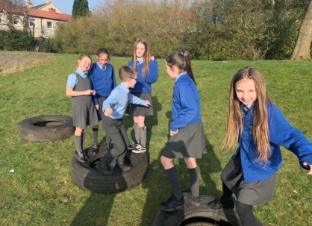

**May Newsletter**

Dear Parents/Carers,

I hope you have enjoyed all the good weather we have had recently. It is a busy final term in St Catherine’s! Please take a note of the dates below there is a lot going on in our school this month

**Dates for your Diary**

*If parents and carers are invited along to a school event, it will state ‘Parents invited’ next to the event.*

**MAY**

**6th – *MAY DAY – school closed***

***7th – INSERVICE DAY – school closed to children***

***11th – P4 First Holy Communions 10.30am at St Catherine Laboure – Parents Invited – more information to follow***

***13th – 17th HMIe Inspectors visiting our school***

***14th  - 2 x P7 children to KNEX final in Riverside Museum***

***15th – Glasgow Counts Multiplication Parents Workshop 9.15am – Parents Invited***

***21st - Book Fayre arrives and here until the 28th – more information to follow***

***23rd – POLLING STATION – school closed to pupils EXCEPT P5 children***

***23rd – P5 children to Belfast – more information to follow***

***23rd – P7s to All Saints for Transition Day 1***

***24th & 27th – MAY HOLIDAY WEEKEND – school closed***

***29th – P5s to Big Yellow Walk***

***29th & 30th – P7s to All Saints for Transition Day 2 & 3***

***31st - Induction Day 1 for our new P1 children in August – Parents Invited***

***Safety of our children***  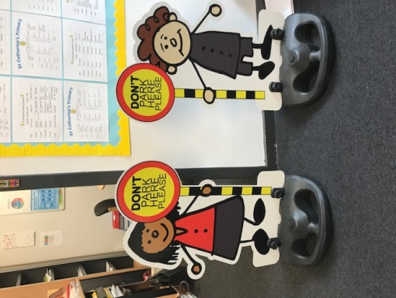

Can I please remind all parents/ carers **Please do not park on the Zig Zags outside the school.**

Recently we have introduced our parking buddies! They are on loan from the Road Safety team at Glasgow City Council. We have had some very positive feedback from parents and they will be staying for a bit longer while we measure the impact. We all have a responsibility for the Health and Safety of our children at St Catherine’s so I would very much appreciate your support in parking responsibly.

**Can I also remind you that all parents and carers must only enter the school building through the front door and report in to the reception. This is to comply with our Child Protection Policy.**

***Church Events*** 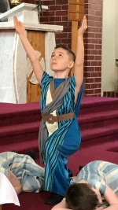

We were so proud of our P3 children who made their First Reconciliation in March. It was a lovely evening and it was great seeing so many our St Catherine’s children celebrating this important sacrament.

We are currently preparing for our P4 children to make their First Holy Communion in May.

All our children took part in a wonderful Passion Play during Holy Week. We were especially impressed with all our P4 actors and P6 readers.

***What’s been happening this month?***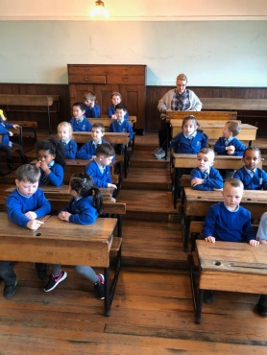

It’s been a busy month for us at St Catherine’s the boys and girls have been out and about enjoying new learning experiences. As well as being out of school we enjoyed a great World Book Day with a series of events around our Bedtime Story Day.

P1a, P1b and P2/1 all visited the local library. We hope to develop this link more over the next few months.

P7b went to Dumfries House and enjoyed Outdoor Learning and Food Technology experiences.

P5 classes and their families did a great job on our Community Litter Pick. Thanks to them all for their hard work.

P1a and P1b went to Scotland Street Museum for a workshop all about Toys in the past. They had lots of fun making and trying out toy from through the ages.

***Family Learning***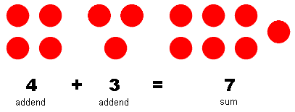

Ms Devlin held the two of four sessions on helping your child with aspects of Maths. We had a great turnout for the addition and subtraction sessions. Next week you are invited to come along to our Multiplication Parents Workshop. They are very informal and designed to support the teaching of maths at all stages. Children will demonstrate learning and you have the chance to see what the children are doing in class. Parents that have attended have found them a real support for helping your child with homework. Please come along 9.15am on Wednesday 15th May.



***Masterclasses***

We started our whole school Masterclasses on Wednesday. These give the children a chance to select an area of the curriculum to develop their skills in. We have a range of masterclasses from Makaton to Basketball and Spanish.

*If you wish to contact me about anything in this newsletter please don’t hesitate to get in touch.*

*Best Wishes*,

***[](http://www.ywcacassclay.org/)***

***Don’t forget to follow us on twitter for all the latest news and pictures - @stcatherinespri***