**St Catherine’s Primary School**

**Love Respect Kindness Inclusion Trust**

**August/ September Newsletter**

Dear Parents/Carers,

Welcome back we are delighted to be kicking off a brand new school year and welcome back all our families. It has been the most challenging time for us all and I am so grateful for all your support while we have put into place our new arrangements. I’d like to take this opportunity to welcome all our new families to St Catherine’s Primary. We hope you enjoy being part of our warm and friendly school community. It’s a very special time and we are delighted to share it with you. We know it has not been what you would normally expect, not being able to be in the school so much but we will continue to be using our See Saw app and our Social Media pages to keep in touch with you and keep you involved with what’s happening in school as often as possible.

**Dates for your Diary**

*If parents and carers are invited along to a school event, it will state ‘Parents invited’ next to the event. With current Scottish Government guidelines currently Parents/ Carers are not able to come into school for events. We will keep you posted of any changes to this.*

***AUGUST***

27th – VIRTUAL Meet the Teacher evening 6.00 – 7.00pm (parents invited, sorry no supervision for children)

29th – First Communions

***SEPTEMBER***

5th – First Communions

12th - First Communions

14th – VIRTUAL Parent Council meeting - *Information to follow*

19th - First Communions

25th – 28th – HOLIDAY WEEKEND – School Closed.

***Safety of our children***  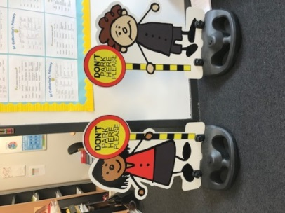

Can I please remind all parents/ carers **Please do not park on the Zig Zags outside the school.**

Following on from the success of the Parking Buddies that were purchased by our Parent Council they will be back soon keeping everyone safe.

**Can I also remind you that all parents and carers are not able to enter the school building due to current restrictions. Please call the office to make an appointment if you feel you need to come into the school.**

*MC900436129[1]****Staffing***

We welcome Miss Reynolds in Primary 5r and Miss Broadley Class Cover Teacher to our staff this session. You will have got the opportunity to meet them all at our Virtual Meet the Teacher night on See Saw. I am sure you will join us in giving them a warm welcome to our school community.

***Breakfast Club / School Meals / Tuck***

MC900001268[1]Can I take this opportunity to remind that our Breakfast Club operates from 8.00 – 8.45 every morning (pupils should arrive no later than 8:30am). This session the charge is £2. per child and £1 if you have an additional child attending. Pupils who are entitled to a free lunch are also entitled to a free breakfast. *This does not include the FREE entitlement for P1-P4. If you think your child is entitled to FREE Breakfast club then you must apply for this through the Grant System.* ***Please note the price of school meals is £1.90 for P5- P7 children.***

This session Cordia have made the decision to remove the tuck shop additional items for children to purchase during breaks and lunch. This is to comply with strict Scottish Government legislation**. *Please make sure you provide your child with a healthy snack for playtime.***

***Allergies***

MC900331294[1]This session we have a number of pupils who have allergies I would ask for your cooperation to help us to ensure they are safe in school. We are already a **nut free school** but some pupils are also allergic to dogs. I would ask all parents to ensure that **no dogs ever come into the school building or school grounds and to try as much as possible to keep them away from the school gates. This includes carrying dogs into the school playground.** I really appreciate your cooperation in this matter regarding children’s health and safety.

***Water***

****Water is so important for keeping your child hydrated throughout the day. Please encourage your child to bring their water bottle to school each day with fresh plain water. They can keep their water on their desk and drink it throughout the day.

***First Communions***

******Congratulations to our P5 children who have made their First Holy Communions last weekend. They were so beautiful and took part in their special mass so well. We are very proud of them. We have more celebrations over the next few weekends and look forward to sharing this special moment with our children.

*If you wish to contact me about anything in this newsletter please don’t hesitate to get in touch.*

*Best Wishes*,

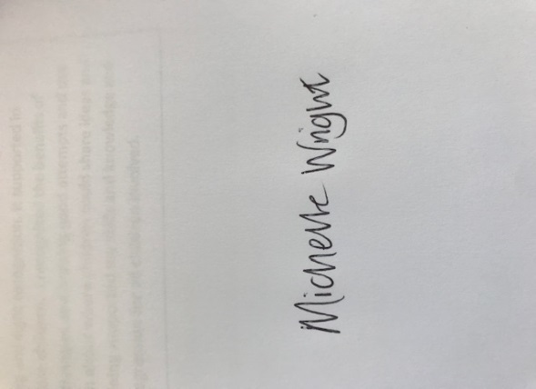

*Michelle Wright*

*Headteacher*

***Don’t forget to follow us on twitter for all the latest news and pictures***

*[](http://www.ywcacassclay.org/)*

[](http://www.google.co.uk/imgres?q=facebook&safe=active&hl=en&biw=1440&bih=731&tbm=isch&tbnid=MpGpuTykj1Ip3M:&imgrefurl=http://www.alvaacademy.clacks.sch.uk/&docid=q3H5bYdE6Tc9bM&imgurl=http://www.alvaacademy.clacks.sch.uk/images/FacebookLogo.png&w=1788&h=594&ei=FKipUtaAOsGjhgfvjoCABA&zoom=1&ved=1t:3588,r:21,s:0,i:156)***- @stcatherinespri - St Catherine’s Primary School Glasgow***