**St Catherine’s Primary School**

**Love Respect Kindness Inclusion Trust**

**August/ September Newsletter**

Dear Parents/Carers,

Welcome back! We are delighted to be kicking off a brand new school year and welcome back all our families. It continues to be a challenging time for us all and I am so grateful for all your support while we keep working within the various mitigations schools have in place to keep our community safe. I’d like to take this opportunity to welcome all our new families to St Catherine’s Primary. We hope you enjoy being part of our warm and friendly school community. It’s a very special time and we are delighted to share it with you. We know it has not been what you would normally expect, not being able to be in the school so much but we will continue to be using our See Saw app and our Social Media pages to keep in touch with you and keep you involved with what’s happening in school as often as possible.

**Dates for your Diary**

*If parents and carers are invited along to a school event, it will state ‘Parents invited’ next to the event. With current Scottish Government guidelines currently Parents/Carers are not able to come into school for events. We will keep you posted of any changes to this.*

***AUGUST***

26th – VIRTUAL Meet the Teacher Videos and Class newsletters are posted on See Saw. New See Saw codes will be sent home.

26th – P5 Multisports afterschool club starts

31st - P4-7 Dance lunch time club starts

31st – Tempest photographers - Individual and sibling school photos.

***SEPTEMBER***

6th – VIRTUAL Parent Council AGM - *Information to follow*

16th – P2 and P3 classes to BBC studios for Swashbuckle TV show filming - *Information to follow*

24th – 27th – HOLIDAY WEEKEND – School Closed.

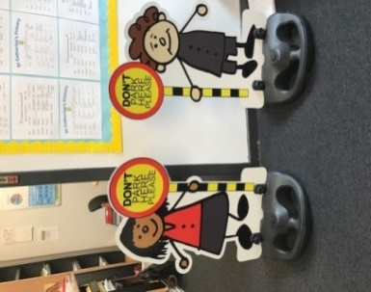

***Safety of our children***

Can I please remind all parents/ carers **Please do not park on the Zig Zags outside the school.**

Following on from the success of the Parking Buddies that were purchased by our Parent Council they will be back soon keeping everyone safe.

***Can I also remind you that all parents and carers are not able to enter the school building due to current restrictions. Please call the office to make an appointment if you feel you need to come into the school.***

*MC900436129[1]****Staffing***

We welcome Mr Bergin in Primary 4f, Miss Ray in P6s, Mr Lawlor in P5a and Miss Quinn in P7q to our staff this session. You will get the opportunity to meet at our Virtual Meet the Teacher night on See Saw if they are teaching your children. I am sure you will join us in giving them a warm welcome to our school community.

***Breakfast Club / School Meals / Tuck***

MC900001268[1]Can I take this opportunity to remind that our Breakfast Club operates from 8.00–8.45am every morning (pupils should arrive no later than 8:30am). This session the charge is £2 per child and £1 if you have an additional child attending. Pupils who are entitled to a free lunch are also entitled to a free breakfast. *This does not include the FREE entitlement for P1-P4. If you think your child is entitled to FREE Breakfast club then you must apply for this through the Grant System.* ***Please note the price of school meals is £1.90 for P5- P7 children.***

***Please make sure you provide your child with a healthy snack for playtime.***

***Allergies***

MC900331294[1]This session we have a number of pupils who have allergies. I would ask for your cooperation to help us to ensure they are safe in school. We are already a **nut free school** but some pupils are also allergic to dogs. I would ask all parents to ensure that **no dogs ever come into the school building or school grounds and to try as much as possible to keep them away from the school gates. This includes carrying dogs into the school playground.** I really appreciate your cooperation in this matter regarding children’s health and safety.

***Water***

****Water is so important for keeping your child hydrated throughout the day. Please encourage your child to bring their water bottle to school each day with fresh plain water. They can keep their water on their desk and drink it throughout the day.

***Lost Property***

Please make sure all items, especially jumpers, cardigans and jackets are labelled. This includes water bottles and packed lunch boxes. We have 386 children all wearing the same clothes and they regularly leave their things down and forget to pick them up. We have a new lost property rail in the foyer and we will regularly post on Facebook items that have gone onto the lost property rail. If you are looking for an item can I ask that you call the office to arrange to check the rail as it is essential we keep visitors to a minimum where possible.

***Uniform***

Our children look so smart in their school uniform and we are very proud of the high standards we have for our uniform. Again this session children should wear PE uniform on PE days. Please do not send children in branded tracksuits etc, it is important to follow the PE uniform guidance.

***COVID UPDATE***

***As numbers rise again it is important to keep our school community safe. Please support us to do this by***

* ***FACE COVERINGS – thank you for your on-going support in wearing face coverings in the playground. We are all working together to play our part***
* ***SOCIAL DISTANCING – please ensure when you are in the yard you maintain 1m distance from anyone that is not in your own household. PLEASE ONLY HAVE ONE ADULT TO COLLECT A CHILD.***
* ***Please ensure you follow the pick up zoned area to try and space out adults in the yard.***
* ***HAND HYGIENE – please use hand sanitizer before and after entering the school grounds and avoid touching our face.***



*If you wish to contact me about anything in this newsletter please don’t hesitate to get in touch.*

*Best Wishes*,

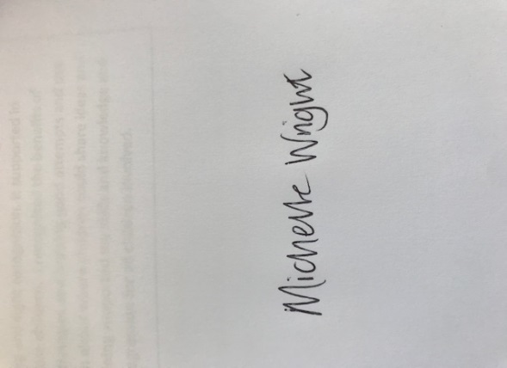

*Michelle Wright*

*Headteacher*

***Don’t forget to follow us on twitter for all the latest news and pictures***

*[](http://www.ywcacassclay.org/)*

[](http://www.google.co.uk/imgres?q=facebook&safe=active&hl=en&biw=1440&bih=731&tbm=isch&tbnid=MpGpuTykj1Ip3M:&imgrefurl=http://www.alvaacademy.clacks.sch.uk/&docid=q3H5bYdE6Tc9bM&imgurl=http://www.alvaacademy.clacks.sch.uk/images/FacebookLogo.png&w=1788&h=594&ei=FKipUtaAOsGjhgfvjoCABA&zoom=1&ved=1t:3588,r:21,s:0,i:156)***- @stcatherinespri - St Catherine’s Primary School Glasgow***

***HOLIDAYS SHEET ATTACHED ON NEXT PAGE***



**St Catherine’s Primary School**

SCHOOL HOLIDAYS SESSION 2021-22

**August**

* Thursday 12 August 2021 (Return date for Teachers & In-Service Day)
* Friday 13 August 2021 (In-Service Day)
* Monday 16 August 2021 (Return date for the pupils)

**September Weekend**

* Friday 24 September 2021
* Monday 27 September 2021

**October**

* Friday 8 October 2021 (In-Service Day)
* Monday 11 to Friday 15 October 2021 (October Week)

**December - Christmas and New Year**

* Schools close at 2.30 pm on Wednesday 22 December 2021
* Thursday 23 December 2021 - Tuesday 4 January (Christmas holidays)

**January**

* Schools return on Wednesday 5 January 2022

**February Mid-term break**

* Monday 14 February 2022
* Tuesday 15 February 2022
* Wednesday 16 February 2022 (In-service day)

**April - Spring Holiday (Easter)**

* Schools close at 2.30 pm on Friday 1 April 2022
* Good Friday 15 April 2022
* Easter Monday 18 April 2022
* Schools return on Tuesday 19 April 2022

**May**

* Monday 2 May 2022 (May Holiday)
* Thursday 5 May 2022 (In-Service day to coincide with Scottish Local Government Elections)
* Friday 27 May 2022

**June**

* Thursday, 2 June 2022
* Friday, 3 June 2022 - Queen's jubilee.
* Schools Close at 1.00 pm on Friday 24 June 2022