**St Catherine’s Primary School **

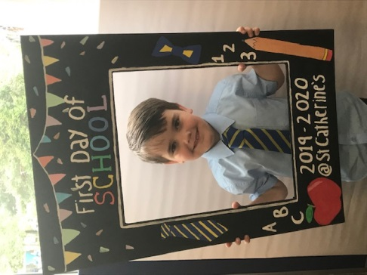

**August Newsletter**

Dear Parents/Carers,

Welcome back we are delighted to be kicking off a brand new school year and welcome back all our families. We hope you have had a great holiday and enjoyed the time away from school. I’d like to take this opportunity to welcome all our new families to St Catherine’s Primary. We hope you enjoy being part of our warm and friendly school community. It’s a very special time and we are delighted to share it with you.

**Dates for your Diary**

*If parents and carers are invited along to a school event, it will state ‘Parents invited’ next to the event.*

***AUGUST***

24th – Meet the Teacher evening 6.00 – 7.00pm (parents invited, sorry no supervision for children)

***SEPTEMBER***

2nd – Parents Confirmation meeting 6.00pm

27th – 30th – HOLIDAY WEEKEND – School Closed.

***Safety of our children***  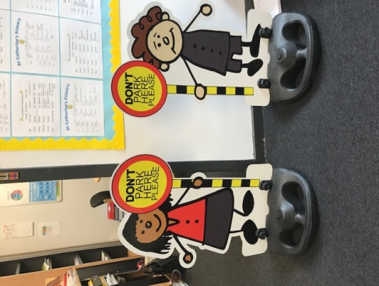

Can I please remind all parents/ carers **Please do not park on the Zig Zags outside the school.**

Following on from the success of the Parking Buddies we got on loan from the Council Road Safety Team our fantastic Parent Council did some fundraising and purchased us our very own Parking Buddies! We are just waiting for these to arrive and we will have them back out on the street.

**Can I also remind you that all parents and carers must only enter the school building through the front door and report in to the reception. This is to comply with our Child Protection Policy.**

MC900436129[1]**Staffing**

We welcome Mrs MacNamee in Primary 5 and Miss Orme in Primary 2 to our staff this session.. You will get the opportunity to meet them all at our Meet the Teacher night. I am sure you will join us in giving them a warm welcome to our school community.

**Breakfast Club / School Meals** / Tuck

MC900001268[1]Can I take this opportunity to remind that our Breakfast Club operates from 8.00 – 8.45 every morning (pupils should arrive no later than 8:30am). This session the charge is £2. per child and £1 if you have an additional child attending. Pupils who are entitled to a free lunch are also entitled to a free breakfast. *This does not include the FREE entitlement for P1-P4. If you think your child is entitled to FREE Breakfast club then you must apply for this through the Grant System.* ***Please note the price of school meals is £1.90 for P5- P7 children.***

This session Cordia have made the decision to remove the tuck shop additional items for children to purchase during breaks and lunch. This is to comply with strict Scottish Government legislation**. *Please make sure you provide your child with a healthy snack for playtime.***

**Allergies**

MC900331294[1]This session we have a number of pupils who have allergies I would ask for your cooperation to help us to ensure they are safe in school. We are already a **nut free school** but some pupils are also allergic to dogs. I would ask all parents to ensure that **no dogs ever come into the school building or school grounds and to try as much as possible to keep them away from the school gates. This includes carrying dogs into the school playground.** I really appreciate your cooperation in this matter regarding children’s health and safety. **Enrolment **

Please note all enrolments are now done through the online enrolment procedures as the authority has centralised these procedures. Should you move house or require to change school at any point in the school year please complete the online enrolment documents on Glasgow City Council’s Website. If you require any assistance or information in relation to this please don’t hesitate to contact the ladies in the office who will advise you.

*If you wish to contact me about anything in this newsletter please don’t hesitate to get in touch.*

*Best Wishes*,

*Michelle Wright*

*Headteacher*

***Don’t forget to follow us on twitter for all the latest news and pictures***

*[](http://www.ywcacassclay.org/)*

[](http://www.google.co.uk/imgres?q=facebook&safe=active&hl=en&biw=1440&bih=731&tbm=isch&tbnid=MpGpuTykj1Ip3M:&imgrefurl=http://www.alvaacademy.clacks.sch.uk/&docid=q3H5bYdE6Tc9bM&imgurl=http://www.alvaacademy.clacks.sch.uk/images/FacebookLogo.png&w=1788&h=594&ei=FKipUtaAOsGjhgfvjoCABA&zoom=1&ved=1t:3588,r:21,s:0,i:156)***- @stcatherinespri - St Catherine’s Primary School Glasgow***