**St Catherine’s Primary School **



**November Newsletter**

Dear Parents/Carers,

We are heading into a very busy time for us in school. Please keep an eye on our Facebook and Twitter pages to make sure you have all the dates and times for the various events happening across the school. I have included all the dates until the end of term to allow you to make any plans. There may be other dates to be added so please keep an eye out for any updates.

**Dates for your Diary**

***December***

***Mass in school every Tuesday & Thursday mornings at 8.40am. All children and families welcome.***

6th – Advent Mass in Church

10th – P4- P6 Christmas Show am - *tickets on sale now*

10th – P1 & P2 Nativity pm - *tickets on sale now*

11th - P1 & P2 Nativity am - *tickets on sale now*

11th - P4- P6 Christmas Show pm - *tickets on sale now*

12th – SCHOOL CLOSED ELECTION DAY – ***school closed to pupils***

13th – P3 & P7 Christmas Tableau in St Catherine’s Church – *more information to follow*

16th – P1 & P2 Christmas Party pm

17th - P5, P6 & P7 Christmas Party pm – PLEASE NOTE CHANGE OF DATE

18th -  P3 & P4 Christmas Party pm - PLEASE NOTE CHANGE OF DATE

18th – P5 – P7 to SECC to Christmas Pantomime

19th – Mass 9.30 am St Catherine’s – all welcome

19th –Last day of Term - ***School Closes 2.30***

**Fundraising Updates**

A huge thank you to everyone involved in supporting our Halloween Discos. I would like to thank the members of Parent Council who did an amazing job decorating the hall and organising a really fun night for all the children. We are still totalling the final amounts but it looks as though we may have raised almost £700 which is a fantastic amount.

We are fundraising hard to make sure we can give the children a fantastic Christmas experience in school. We have booked for a show to come in for the P1-4 children for Christmas and are currently organising something similar for the P5 – P7 children.

A big thank you to all who donated bottles at our recent Dress Down Day. These will go towards creating a brilliant tombola as well as raffles.

If you have any raffle prizes or know anyone you think might be willing to support us with a raffle prize please get in touch!

Don’t forget to get your ladies night tickets for the 22nd November. It is sure to be a brilliant night!

**Anti Bullying Week** 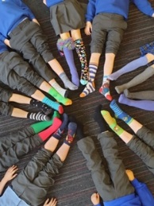

We are working hard to raise awareness of the impact bullying can have on our young people’s lives. This week is Anti Bullying Week and there are lotsof activities happening in school to support this. Including the Odd Socks Day, which really encouraged us to think about and celebrating differences.

**Committees**

We have started our Whole School Committees. Every child in our school is involved in a committee for something. We want to give every child a voice and a say in how we make our school the very best it can be.

**Sports News** 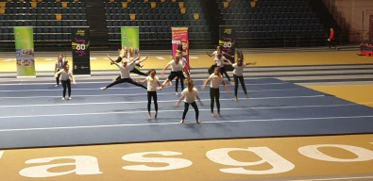

Our Gymnasts were amazing at the Gymfest Festival today in the Emirates Arena. Our Football Team are needing some home support to encourage them to victory. If you are interested in helping or supporting the team – please get in touch. We have a new Basketball Team who are playing as part of a local league in All Saints every week. We have a team heading off to the Dance Festival heats on Thursday – Good luck everyone!

*If you wish to contact me about anything in this newsletter please don’t hesitate to get in touch.*

*Best Wishes*,

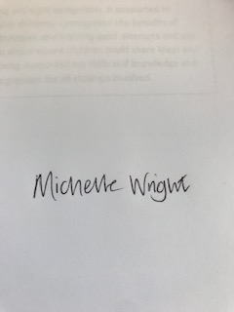

*Mrs Michelle Wright*

*Headteacher*

*[](http://www.ywcacassclay.org/)****Don’t forget to follow us on twitter for all the latest news and pictures***

[](http://www.google.co.uk/imgres?q=facebook&safe=active&hl=en&biw=1440&bih=731&tbm=isch&tbnid=MpGpuTykj1Ip3M:&imgrefurl=http://www.alvaacademy.clacks.sch.uk/&docid=q3H5bYdE6Tc9bM&imgurl=http://www.alvaacademy.clacks.sch.uk/images/FacebookLogo.png&w=1788&h=594&ei=FKipUtaAOsGjhgfvjoCABA&zoom=1&ved=1t:3588,r:21,s:0,i:156)***- @stcatherinespri - St Catherine’s Primary School Glasgow***