**St Catherine’s Primary School**



**December Newsletter**

Dear Parents/Carers,

We are all planned for a very busy December. Apologies for the delay in our newsletter we were waiting to have confirmation of our date for finishing up. Despite the challenges this pandemic brings it is lovely to see the children so excited for all the festivities.

**DATES FOR YOUR DIARY**

|  |  |
| --- | --- |
| **FRIDAY 11TH DECEMBER** | CHRISTMAS JUMPER DAY  Wear your Christmas Jumper to School!  SANTA VISIT FOR P1, P2, P3 |
| **TUESDAY 15TH DECEMBER** | JAMMIE DAY  Wear your jammies to school to watch a film and have a hot chocolate! |
| **THURSDAY 17TH DECEMBER** | CHRISTMAS LUNCH – P1, P4, P6  VIRTUAL PANTO – P4 & P5 (Pupils in these classes can wear their own clothes today) |
| **FRIDAY 18TH DECEMBER** | CHRISTMAS LUNCH – P2, P3, P5, P7  VIRTUAL PANTO – P6 & P7 (Pupils in these classes can wear their own clothes today) |
| **MONDAY 21ST DECEMBER** | VIRTUAL PANTO – P1 & P2 (Pupils in these classes can wear their own clothes today) |
| **TUESDAY 22ND DECEMBER** | VIRTUAL PANTO – P3 (Pupils in these classes can wear their own clothes today)  SCHOOL CLOSES 2.30PM |
| **WEDNESDAY 6TH JANUARY** | SCHOOL RE-OPENS |

**Water Bottles**

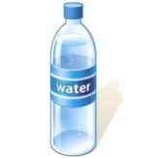Can I remind parents/ carers to please encourage children to send children to school with water bottles filled with plain water. It is so important for children to stay hydrated throughout the school day and plain water is proven to be better for this and better for children’s teeth than juice.

**Christmas Food Appeal**

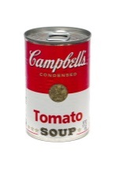

A huge thank you to everyone who has supported our Food Collection. If you or someone you know, perhaps a relative or neighbour would benefit from one of our Food Parcels this Christmas please get in touch with Mrs Wright at the school and your request will be dealt confidentially.

**COVID – 19 Guidance**

**Just like everyone else, our staff are hoping to spend time with loved ones this Christmas. It is so important as we head towards the end of term that no one has to Self-Isolate. If your child has any of the following symptoms please do not send them to school.**

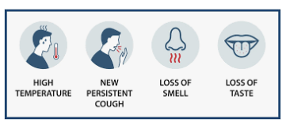

**Can I remind you as we approach the end of term to please keep going with the Scottish Government Guidance to help keep our communities safe.**

* ***FACE COVERINGS – thank you for your on-going support in wearing face coverings in the playground. We are all working together to play our part***
* ***SOCIAL DISTANCING – please ensure when you are in the yard you maintain 2m distance from anyone that is not in your own household. PLEASE ONLY HAVE ONE ADULT TO COLLECT A CHILD.***
* ***Please ensure you follow staggered start and finish times and send older children in for these to reduce the amount of time children and adults are in the yard in the mornings.***
* ***HAND HYGIENE – please use hand sanitizer before and after entering the school grounds and avoid touching our face.***

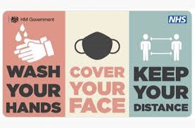

*I’d like to take this opportunity to wish you all a very happy Christmas when it comes. Thank you for all your hard work and support throughout the year. Have a lovely and peaceful holiday.*

*If you wish to contact me about anything in this newsletter please don’t hesitate to get in touch.*

*Best Wishes*,

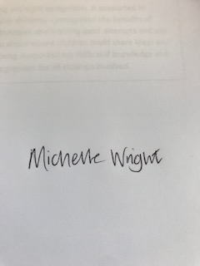

*Mrs Michelle Wright*

*Headteacher*

*[](http://www.ywcacassclay.org/)****Don’t forget to follow us on twitter for all the latest news and pictures***

[](http://www.google.co.uk/imgres?q=facebook&safe=active&hl=en&biw=1440&bih=731&tbm=isch&tbnid=MpGpuTykj1Ip3M:&imgrefurl=http://www.alvaacademy.clacks.sch.uk/&docid=q3H5bYdE6Tc9bM&imgurl=http://www.alvaacademy.clacks.sch.uk/images/FacebookLogo.png&w=1788&h=594&ei=FKipUtaAOsGjhgfvjoCABA&zoom=1&ved=1t:3588,r:21,s:0,i:156)***- @stcatherinespri - St Catherine’s Primary School Glasgow***