**St Catherine’s Primary School**



**December Newsletter**

Dear Parents/Carers,

Please find attached the key dates for this Christmas. We are still not quite back to normal, however we are excited to celebrate with the children with the most fun as possible. We hope we will have you back in with us again next year!

**DATES FOR YOUR DIARY**

|  |  |
| --- | --- |
| **FRIDAY 3rd DECEMBER** | Christmas Tombola - 2pm Infant Yard – adults only |
| **Week Beginning**  **MONDAY 6TH DECEMBER** | ONLINE PANTO FOR ALL CLASSES |
| **FRIDAY 10th DECEMBER** | CHRISTMAS JUMPER DAY  Wear your Christmas Jumper to School! |
| **TUESDAY 14TH DECEMBER** | P1 & P2 CHILDREN’S NATIVITY – ONLINE RECORDING WILL BE SHARED  CHRISTMAS LUNCH – FOR ALL CHILDREN |
| **THURSDAY 16TH DECEMBER** | P4, P5, & P6 CHILDREN’S CHRISTMAS SHOW– ONLINE RECORDING WILL BE SHARED  P3 & P7 CHRISTMAS TABLEAUX RECORDING WIL BE SHARED  P1 & P2 CHRISTMAS PARTIES – children can wear their own clothes to school – with a special visitor!! |
| **FRIDAY 17th DECEMBER** | P3 & P4 CHRISTMAS PARTIES – children can wear their own clothes to school – with a special visitor!! |
| **MONDAY 20th DECEMBER** | P5 & P6 CHRISTMAS PARTIES – children can wear their own clothes to school |
| **TUESDAY 21st DECEMBER** | P7 CHRISTMAS PARTIES – children can wear their own clothes to school |
| **WEDNESDAY 22nd DECEMBER** | SCHOOL CLOSES 2.30PM |
| **WEDNESDAY 5th JANUARY** | SCHOOL RE-OPENS |

**Christmas Food Appeal**

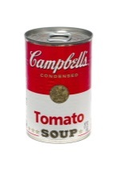

We will be running our annual Food Collection event again this year with P7 for their Pope Francis Faith Award work. If you or someone you know, perhaps a relative or neighbour would benefit from one of our Food Parcels this Christmas please get in touch with Mrs Wright at the school and your request will be dealt confidentially.

**COVID – 19 Guidance**

**Just like everyone else, our staff are hoping to spend time with loved ones this Christmas. It is so important as we head towards the end of term that no one has to Self-Isolate. If your child has any of the following symptoms please do not send them to school.**

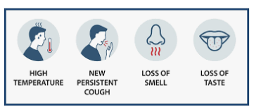

**Can I remind you as we approach the end of term to please keep going with the Scottish Government Guidance to help keep our communities safe.**

* ***FACE COVERINGS – thank you for your on-going support in wearing face coverings in the playground. We are all working together to play our part***
* ***SOCIAL DISTANCING – please ensure when you are in the yard you maintain 2m distance from anyone that is not in your own household. PLEASE ONLY HAVE ONE ADULT TO COLLECT A CHILD.***
* ***HAND HYGIENE – please use hand sanitizer before and after entering the school grounds and avoid touching our face.***

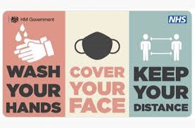

*I’d like to take this opportunity to wish you all a very happy Christmas when it comes. Thank you for all your hard work and support throughout the year. Have a lovely and peaceful holiday.*

*If you wish to contact me about anything in this newsletter please don’t hesitate to get in touch.*

*Best Wishes*,

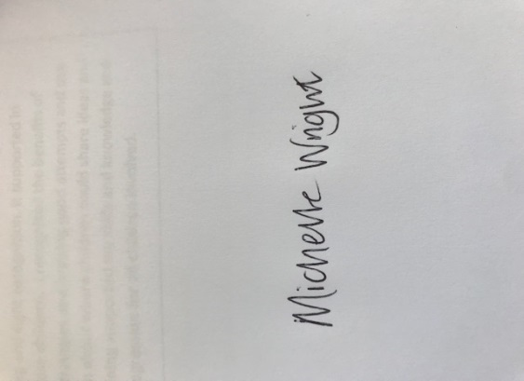

Mrs Michelle Wright

Headteacher

*[](http://www.ywcacassclay.org/)****Don’t forget to follow us on twitter for all the latest news and pictures***

[](http://www.google.co.uk/imgres?q=facebook&safe=active&hl=en&biw=1440&bih=731&tbm=isch&tbnid=MpGpuTykj1Ip3M:&imgrefurl=http://www.alvaacademy.clacks.sch.uk/&docid=q3H5bYdE6Tc9bM&imgurl=http://www.alvaacademy.clacks.sch.uk/images/FacebookLogo.png&w=1788&h=594&ei=FKipUtaAOsGjhgfvjoCABA&zoom=1&ved=1t:3588,r:21,s:0,i:156)***- @stcatherinespri - St Catherine’s Primary School Glasgow***