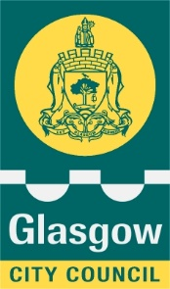

**Executive Director of Education Services**

**Education Glasgow City Council**

Maureen McKenna City Chambers East Building

40 John Street

Glasgow G1 1JL

Our Ref MMcK/SMcC

Date 13 September 2021

Dear Parent/Carer

Free School Meals – October Holiday Payment Eligibility

It is not long until the schools break for the October holiday and I wanted to inform parents and carers with P1 – S6 children and young people, who currently meet the eligibility criteria for free school meals, that they will receive an additional one-off October holiday payment of £172.50 per child from Friday 8 October 2021.

This is part of the Scottish Government’s on-going pandemic financial support.

You **do not need** to contact us or make a new application if your family is already in receipt of free school meals and if you have received previous free school meal holiday payments in the last 18 months.

The money will automatically be paid directly into your bank account by 8 October.

All P1 to P4 pupils receive the universal meal at school however only the families eligible on financial grounds will receive this additional payment.

New applicants who apply before 24 September 2021 and meet the eligibility criteria will be paid the £172.50 additional October holiday payment and will receive this from 8 October.

New applications received between 25 September – 10 October and meet the eligibility criteria will be paid by 12 November.

Unfortunately, applications received after 10 October and meet the criteria will only receive free school meals payment and not the additional October holiday payment.

If you think that your family might qualify for free school meals please visit our website to find out more details on the eligibility criteria and fill out an application at <https://www.glasgow.gov.uk/schoolsandlearning>  - there’s also a list of frequently asked questions which may help with any enquiry you have.

Yours sincerely

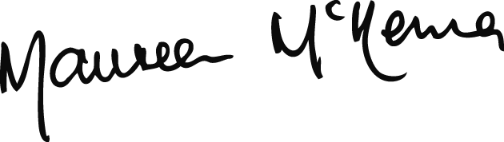

**MAUREEN McKENNA**

Executive Director of Education Services