St Catherine’s
Primary School

Getting Ready for Primary 1
Family Learning Booklet

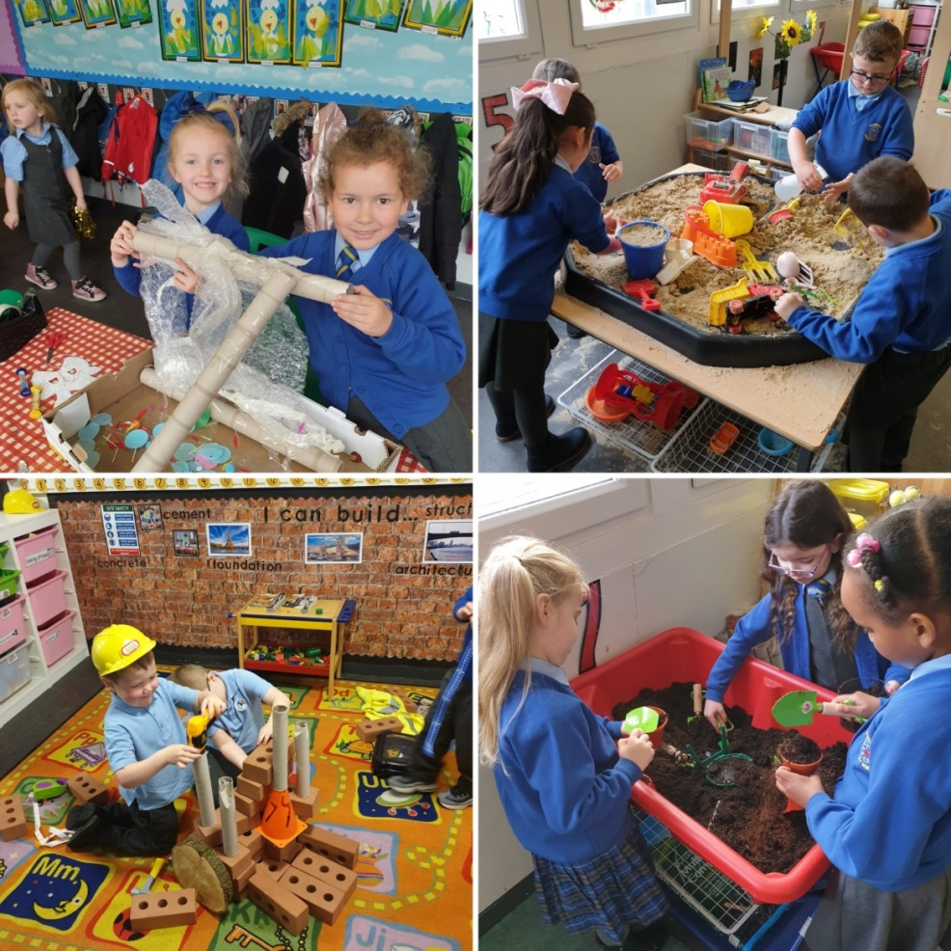

Dear Parents/Carers,

As part of our Primary 1 family transition programme, we would have normally had a dedicated four session programme in school.
The children would have had the opportunity talk about what to expect when they start Primary 1 and would have completed activities related to the book, Harry and the Dinosaurs go to School.
Due to the recent Covid 19 pandemic we have had to “think outside the box” and look at ways we can best prepare children and families for starting Primary 1 in August.
Here are some simple activities we hope you will enjoy.

We look forward to seeing you all in August.

Miss Reynolds
DHT

All About Me
My name is __________________.

This is me!
(this can be a drawing or picture)

I am ______ years old.
My favourite food is _________________.
My favourite story is _________________.
I love _________________________.
My Skills: What can you tick off?
It is important that children learn socialisation skills at home as well as school. Ways in which you can help your child prepare is by encouraging them, modelling for them and showing them how to do a variety of basic social skills e.g.

I can take turns. |  | I can zip up my jacket.
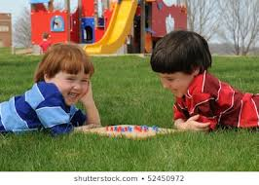 |  | 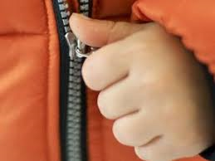

I can go to the toilet  myself. |  | I can wash and dry my  own hands.
 |  | 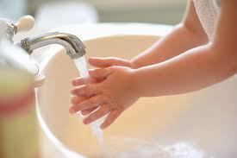

I can put my shoes on. |  | I can use cutlery.
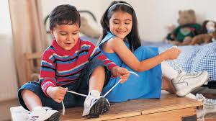 |  | 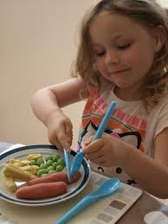
I can use a tissue and  blow my nose. |  | I can use scissors safely.
 |  | 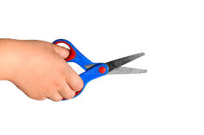

I can say please and thank  you. |  | I can dress myself.
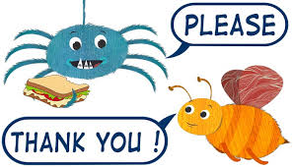 |  | 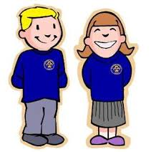

Family Together Time Activities
Activity Idea 1: Listen to the story Harry and the Dinosaurs go to school.
You can hear Miss Reynolds read it on the school website or you can access it on Tube https://www.youtube.com/watch?v=e87RI11rzRs
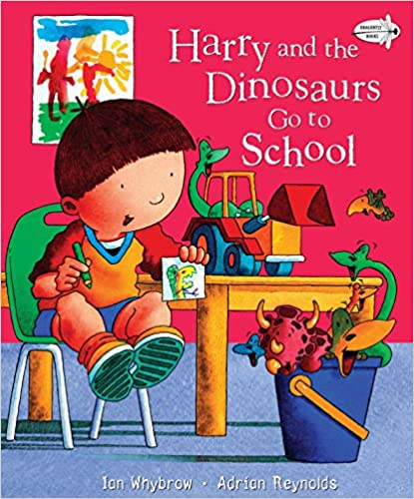

Now discuss these questions with your child.

How is Harry feeling before he goes to school? How do you feel?
Harry’s favourite toys are his? He takes them in a …….?
Who takes Harry to school on his first day?
What’s Harry’s teacher’s name?
How does Harry feel about the playground?
What toy does the little boy in his class who cries all the time have?
What does Harry offer to do with his new friend?
What do they do as their first activity at school?

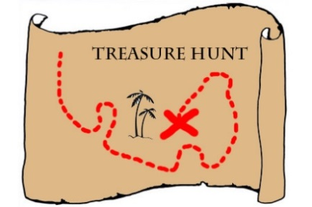
Activity Idea 2: Alphabet Treasure Hunt

Parent: Write the alphabet from a – z on little bits of paper and place around the house. Ask your child to go around the house collecting as many alphabet letters as they can. When they collect all of them play a game of placing them in order. See if your child can repeat after you for example: a for apple, b for ball. Then ask what does the letter of your name start with? Your favourite toy? Story? TV programme?
You could do this with the numbers 0 – 10 too.
(This can be done inside or outside)
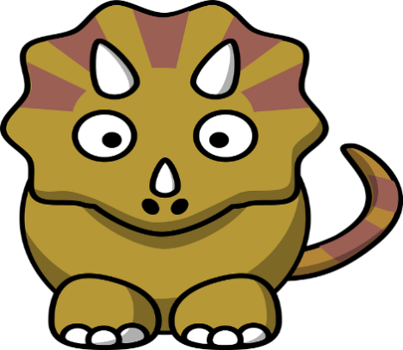
Activity Idea 3: Dinosaur Peg Counting

Together cut out 10 dinosaurs (included in the pack) or draw your own. Write the numbers 0 – 10 on each dinosaur giving them a number. Then with your child put all of the dinosaurs face down and ask them to pick a card. Ask the child to say the number and clip the amount of pegs to the number on the dinosaur picture.
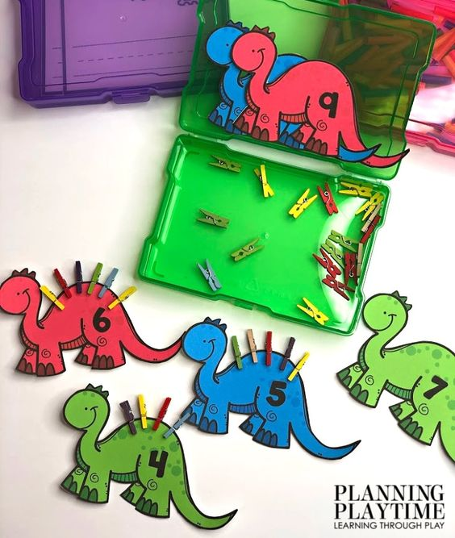
(This can be done inside or outside)

Templates:

Activity Idea 4: Make my own Dinosaur
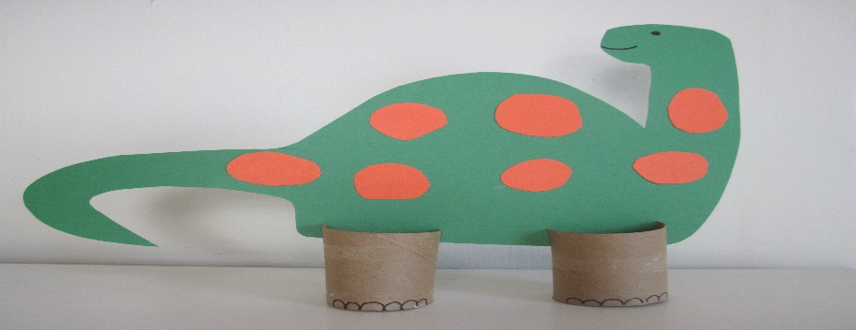
Together with your child use boxes/ toilet rolls and anything you can find in the paper recycling bin/ old magazines, tape, pens and glue.
Ask your child to build their very own Dinosaur- ask them to give it a special name and special powers.
(This can be done inside or outside)

