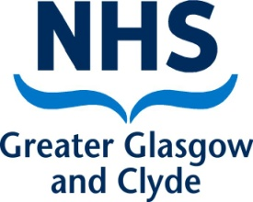
Public Health
West House
Gartnavel Royal Hospital
1055 Great Western Road
Glasgow G12 0XH
0141 201 4917
E-mail: phpu@ggc.scot.nhs.uk
Our Ref: Schoolcovid19/A
Dear Parent/Carer

I am writing to let you know that our Test and Protect team is carrying out COVID-19 contact tracing at your child’s school.

Working closely with the school and local authority, NHS Greater Glasgow and Clyde has carried out a careful risk assessment to establish a list of close contacts within the school.

All close contacts are being advised to self-isolate as a precaution and being given appropriate advice and support. The school will work with parents and carers to minimise the disruption to learning for those pupils who need to self-isolate.

Robust control measures are in place at the school, and there is currently no evidence of transmission within the school itself. If you do not receive a further letter from Public Health then your child/ren can continue to go to school as normal.

I would like to take this opportunity to remind you of the general advice currently in place for everyone: If anyone in your household develops symptoms of COVID19 the symptomatic person should self-isolate and be tested as soon as possible. Everyone else in the household should also stay at home if someone you live with or someone in your extended household has symptoms. The symptoms include:
- a high temperature or fever
- a new continuous cough
- a loss of, or change in sense of smell or taste.

I would also like to remind all pupils and their parents of the vital importance of continuing to observe the rules on social distancing and other measures to prevent infection such as regular handwashing.

Further information on COVID-19 including on what to do if you develop symptoms and how to access a test is available from NHS Inform: https://www.nhsinform.scot/illnesses-and-conditions/infections-and-poisoning/coronavirus-covid-19. Frequently Asked Questions for schools are available at https://www.nhsggc.org.uk/your-health/health-issues/covid-19-coronavirus/for-patients-the-public/schools-info/faqs/#.

Yours faithfully
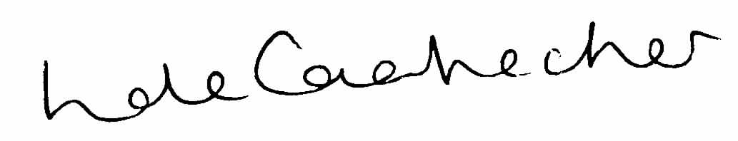
Linda de Caestecker
Director of Public Health
NHS Greater Glasgow and Clyde

