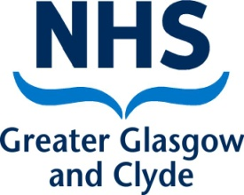
Public Health
West House
Gartnavel Royal Hospital
1055 Great Western Road
Glasgow G12 0XH

Our Ref: Schoolscovid/B(CT)
Dear Parent or Carer

I write to confirm that your child has been identified as a close contact of a person who has Covid-19. As your child was in close contact with this person at school they are required to self-isolate for 10 days as a precaution. They should not attend school during this time. The school will advise how they will support your child’s learning while they are unable to attend school.

The 10 days starts from the date your child was last in contact with the person who has Covid-19. If your child does not develop any symptoms of Covid-19 while isolating, the last day of their self-isolation will be 2.4.21 so can return to school on 19.4.21.

You are also advised to arrange a Covid-19 PCR test for your child, unless they have tested positive within the last 90 days. You can book a test by visiting https://www.nhsinform.scot/illnesses-and-conditions/infections-and-poisoning/coronavirus-covid-19/test-and-protect/coronavirus-covid-19-testing. If you need support to book a test, please call 0300 303 2713.
- If the test is positive: If your child’s test is positive for Covid-19 your whole household should self-isolate and you will be contacted by NHS Scotland’s Test and Protect Service.
- If the test is negative: If your child’s test is negative for Covid-19 they should continue to isolate. This will not change the date your child can return to school. Other members of your household, including any other children, do not need to self-isolate unless they are also a close contact of a person with Covid-19 infection.

As a reminder, symptoms of Covid-19 include:
- a high temperature or fever
- a new continuous cough
- a loss of, or change in sense of smell or taste
If you or any of your household develops symptoms then all household members must self-isolate. A test should be booked as soon as possible for anyone who has symptoms.

Should you require any further information about Covid-19, please visit the NHS Inform website https://www.nhsinform.scot/illnesses-and-conditions/infections-and-poisoning/coronavirus-covid-19. If you need support while self isolating, and can’t get this from friends or family, the National Assistance Helpline is there to help and can be reached on 0800 111 4000.

Yours faithfully,
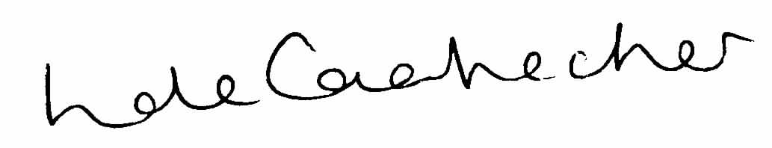

Linda de Caestecker
Director of Public Health, NHS Greater Glasgow and Clyde

