
Public Health
West House
Gartnavel Royal Hospital
1055 Great Western Road
Glasgow G12 0XH

Our Ref: Schoolscovid/B(NR)
Dear Parent or Carer,

I write to confirm that your child has been identified as a close contact of a person who has Covid-19. As your child was in close contact with this person at school they are required to self-isolate for 14 days as a precaution. They should not attend school during this time.

The school will advise how they will support your child’s learning while they are unable to attend school.

The 14 days starts from the date your child was last in contact with the person who has Covid-19. If your child does not develop any symptoms of Covid-19 while isolating, the last day of their self-isolation will be 8.6.21 so can return to school on 9.6.21.

Other members of your household, including any other children, do not need to self-isolate unless they are also a close contact of a person with Covid-19 infection. If you or any of your household develops symptoms then all household members must self-isolate. A test should be booked as soon as possible for anyone who has symptoms. If a test is required, you can arrange this via NHS inform: https://www.nhsinform.scot/illnesses-and-conditions/infections-and-poisoning/coronavirus-covid-19/test-and-protect/coronavirus-covid-19-testing

As a reminder, symptoms include:
- a high temperature or fever
- a new continuous cough
- a loss of, or change in sense of smell or taste

A test is not needed unless you have symptoms or the Test and Protect team ask you to get a test. If your child does have a negative test this will not change the date your child can return to school.

Should you require any further information about Covid-19, please visit the NHS Inform website https://www.nhsinform.scot/illnesses-and-conditions/infections-and-poisoning/coronavirus-covid-19. Frequently Asked Questions for schools are available at https://www.nhsggc.org.uk/your-health/health-issues/covid-19-coronavirus/for-patients-the-public/schools-info/faqs/#. If you have questions about the contact tracing process that are not addressed by these resources you can email the Test and Protect service on ggctestandprotect@ggc.scot.nhs.uk

Yours faithfully,
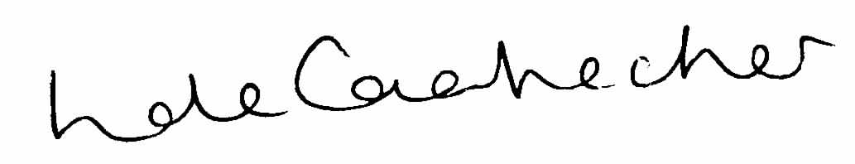

Linda de Caestecker
Director of Public Health
NHS Greater Glasgow and Clyde

