Literacy at the Early Level
Primary 1
Parent Guide
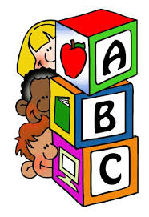

Ways in which you can support your child in literacy at the Early Level
How you can help your child with phonics?
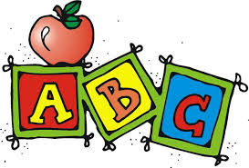
- Go over the letters that are sent home. Do this regularly as quick recognition is needed. Make it fun – play bingo, snap or pairs games.
- Ask your child to show you the action for each letter.
- Let them write the letters.
- Make simple words together.
- Revise nursery rhymes. Play games with nursery rhymes, miss out parts, and make mistakes. Talk about why words rhyme.
- Look for letters in the environment.
- Listen to your child express their thoughts and ideas.

How can you help your child with reading?
- Go over the words with your child as much as you can. Make sure the atmosphere is right. REMEMBER FLUENCY AND SPEED OF RECALL IS CRUCIAL. Make it fun and join in.
- Read their book with them. If they hear an adult reading well, they will model the reading. Let them read the book to you. They may want to read it a few times. Speak about the book.
- Praise, praise and praise their efforts.
- Ask if you need help or advice.

How can you help your child with writing?
- Encourage your child to write letters he/she is learning at school. They may want you to write a story to go with a picture. Write it and then read it to them speaking about the words you have written. Encourage and praise them as there is a lot to remember.
- Use magnetic letters/sound bags to make words. Write these words, soon it will be sentences.
- Use the words in the tin to build sentences.
- Let them cut, paint, draw and write – this helps them to remember.
- When you write, tell them what you are writing.

PLEASE ENCOURAGE YOUR CHILD TO WRITE – ALWAYS KEEP AN EYE ON THEIR PENCIL GRIP AND THE STARTING POSITION OF EACH LETTER WHEN THEY ARE WRITING.

