**St Catherine’s Primary School **

**March Newsletter**

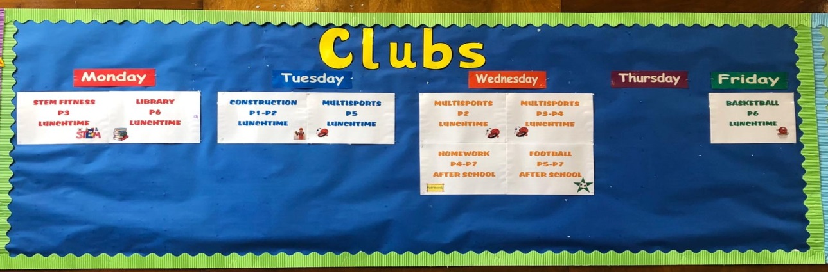

Dear Parents/Carers,

We have had a very busy term so far and there are always lots of things going on in our school. Please keep an eye on our Facebook and Twitter pages to make sure you have all the dates and times for the various events happening across the school and all the great pictures of the fun we have while we are learning.

**Dates for your Diary**

***March***

***Mass in school every Tuesday & Thursday mornings at 8.40am. All children and families welcome.***

4th – International Women’s Day event Niamh our School Captain and 1 other girl to attend event in City Chambers

10th - Parent Council Meeting 6.30pm in school – all welcome

12th – Reconciliation - P3 children to celebrate the sacrament of reconciliation in St Catherine’s Church

13th – P5/4 and P4/3 to Dynamic Earth, Edinburgh

18th – P5s to Glasgow Green for Bikability Event

26th & 27th – Fluoride Varnish – more info to follow.

30th – P3 Children to Swashbuckle Cbeebies show

**Trips** 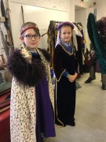

We have been working really hard to ensure the children get out and about and have the opportunity to put their learning into context. Some of our recent trips include P6’s trip to Stirling to support their Interdisciplinary Learning Topic. P5 were at the Museum on the Mound in Edinburgh to develop their understanding of Financial Education and money. P6 went to the Science Centre to support their Science learning in class and enjoyed workshops as well as visiting the centre. P5/4 and P4/3 are heading to Dynamic Earth soon to develop their learning in Science. All P3 children are going to the BBC Scotland studios to be audience and participants on the Swashbuckle TV show.

**Uniform** 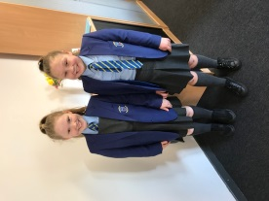

Can I take this opportunity to thank Parents/ Carers for your commitment to our uniform. Our children in the majority are always so smart in their Shirts and Ties every day. Our uniform makes us so smart and shows our commitment to being smart and ready to learn as part of our St Catherine’s Family. Can I please remind all parents/carers that our uniform consists of grey trousers/ skirt, light blue shirt and blue school jumper/ cardigans. Hoodies and zipper tops that are not part of our uniform are discouraged. Footwear should be black shoes/ trainers. Please do not send children in with white trainers or coloured shoes. Except for very wet weather when the children are wearing their wellies!

There was some discussion at our last parents council meeting around the tartan skirts that are starting to be worn. Opinions are divided on this topic so we will shortly undertake a parents consultation. We will need to make sure if we are going ahead with this we choose one tartan and that is introduced as part of the official uniform. Please note currently this is not part of our uniform.

**Vision and Values**

At our last Parents Meetings we asked you to participate in the creation of our new School Vision and Values. It has been lots of work pulling together the Vision Statements and Values from that. All members of our school community have been involved in that work. I have included a copy of this attached to our newsletter.

Clubs 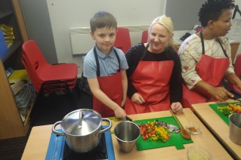

We have lots of exciting lunchtime and afterschool clubs running this term with new clubs starting regularly. This term we have sports, cooking, library and homework. We tracked the involvement of all children to try and ensure we organise things that meet the need of as many children as possible. We always welcome any thoughts about clubs. At the start of the newsletter we have the clubs display board that is in the hall. To be added to this is French and Choir. There is also an Art club coming soon!

*If you wish to contact me about anything in this newsletter please don’t hesitate to get in touch.*

*Best Wishes*,

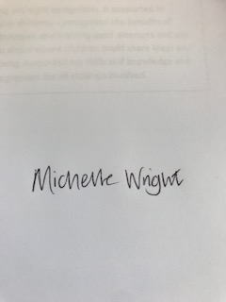

*Mrs Michelle Wright*

*Headteacher*

***Don’t forget to follow us on twitter for all the latest news and pictures***

[](http://www.google.co.uk/imgres?q=facebook&safe=active&hl=en&biw=1440&bih=731&tbm=isch&tbnid=MpGpuTykj1Ip3M:&imgrefurl=http://www.alvaacademy.clacks.sch.uk/&docid=q3H5bYdE6Tc9bM&imgurl=http://www.alvaacademy.clacks.sch.uk/images/FacebookLogo.png&w=1788&h=594&ei=FKipUtaAOsGjhgfvjoCABA&zoom=1&ved=1t:3588,r:21,s:0,i:156)***- @stcatherinespri - St Catherine’s Primary School Glasgow***