Numeracy at the Early Level
Primary 1

Parent Guide

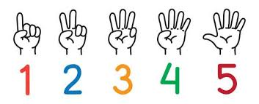

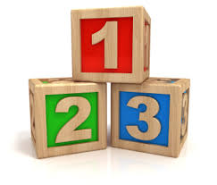

Number and Number Processes – How Can You help?
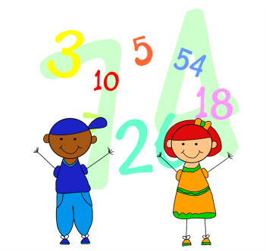
- Let your child see you counting. Count everyday objects –
stairs, buttons on clothes etc – touch each thing as you
count it.
- Sing simple number rhymes and songs – 10 green bottles,
1 2 3 4 5 once I caught a fish alive etc.
- Play board games/dice games/card games/dominoes – have
the child count the number.
- Use sand, playdough/plasticine to form numbers.
- Look out for numbers in the newspaper, cut them out, put them in order.
- Make a counting book – stick in or draw the corresponding number of objects
- Look for numbers in the environment – clocks, phones, calendars.
- Ask your child to bring you 2 pens, 6 spoons etc.
- Tap your finger x times – ask your child to point to the correct numeral.

Patterns and Relationships – How can you help?

- Identify and talk about patterns in the environment – brickwork, flowerbeds, flats, wallpaper, fabric etc.
- Copy and create patterns with beads, coloured toys, crayons, coins etc.

Addition and Subtraction – How can you help?

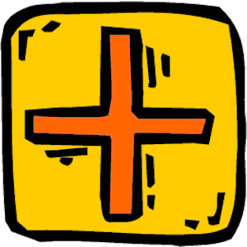
- Use 2 plates – how many different ways can you arrange 6 biscuits on the plate e.g. 5 and 1, 4 and 2 etc.
- Make 8 as many different ways as you can – vary
the objects used. Ask your child to record what they
found. They might use drawing numbers etc.
- Look at dominoes and find all the ones that have a
total of ‘x’ dots.
- Skittles – number your skittles. Knock down skittles and add
the numbers of the skittles that have fallen.
- Play board games – use 2 die. Throw both and add the numbers
together, move that number of spaces.
- Make up a simple bingo game. Choose 6 numbers between 0 and 10
(and beyond) and write the numbers down on the bingo grid. Ask
each other sums.

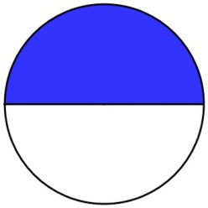
Fractions – How can you help? $\frac{1}{2}$
- Cut fruit into pieces and talk about how many
pieces make up the whole fruit. one half
- Share out sweets between everyone in the family.
How many does each person get?

- Share out snacks so everyone has the same number.

