**St Catherine’s Primary School**

**Love Respect Kindness Inclusion Trust**

**November Newsletter**

Dear Parents/Carers,

Here we are into Term 2 already and the weather has certainly been changing. It’s been another challenging start to the year and I am very grateful to our whole school community for working together to keep Coronavirus away from our school as much as possible.

***Safety of our children***

We have changed our morning routines for the P1 – P3 children. All infant children will be dropped at the gate between 8.45 – 9.00, they will enjoy a bit of play in the yard before joining their lines at 9.00. The yard is fully supervised with Support for Learning Workers staff and members of the Senior Leadership Team. Can I kindly ask that you don’t gather directly at the gate in the morning to give plenty of space for the drop offs – Thanks!

**Can I also remind you that all parents and carers are not able to enter the school building due to current restrictions. Please call the office to make an appointment before coming to the school office.**

***COVID UPDATE***

* ***FACE COVERINGS – thank you for your on-going support in wearing face coverings in the playground. We are all working together to play our part.***
* ***SOCIAL DISTANCING – please ensure when you are in the yard you maintain 2m distance from anyone that is not in your own household. PLEASE ONLY HAVE ONE ADULT TO COLLECT A CHILD.***
* ***HAND HYGIENE – please use hand sanitizer before and after entering the school grounds and avoid touching our face.***

***Outdoor Education and play***

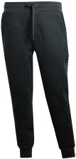In line with current guidelines we encourage the children, where possible, to be outside for breaks and lunchtime. Please ensure the children have a winter jacket on to keep them warm. As the days get colder it may also be necessary for the children to wear additional warmer layers to school as we still need to keep classroom windows open for effective ventilation. Children can wear additional zipper jackets or t-shirts and layers under jumpers to keep them warm in class whenever required.

Although we are now beginning to bring PE indoors we are not able to use the changing rooms. Please ensure children still come to school on PE days in Dark joggers and school jumper on top**. Please remind children PE days are NOT non uniform days. Please adhere to the PE uniform and avoid branded items.**

***Water***

Water is so important for keeping your child hydrated throughout the day. Please encourage your child to bring their water bottle to school each day with fresh plain water. They can keep their water on their desk and drink it throughout the day.

***Mass***

******All our children have been getting the opportunity to attend mass in stages. We also have led the Holy Rosary in the month of October in church. Father Gallagher joined us in school this week for work creating a school prayer – we look forward to sharing this with you soon. All mass times on the St Catherine Laboure Facebook.

***Halloween ***

******We will be having Halloween Parties in the hall in stages from P1 – P7 on Friday 29th October. Our theme this year is Eco’een and we encourage you to create costumes from things you have in the house for example a robot from boxes or a witch with a bin bag cloak. Some of you might be old enough to remember this from your own childhood? I certainly am! We will have prizes for homemade costumes but if you can’t manage this the children can dress up in a bought costume but nothing scary or inappropriate for school. Children can wear their costumes all day in school. The Parent Council raffle will be drawn on Halloween and they will also be organising treats for the children to purchase – we will send out more details about that shortly.

*If you wish to contact me about anything in this newsletter please don’t hesitate to get in touch.*

*Best Wishes*,

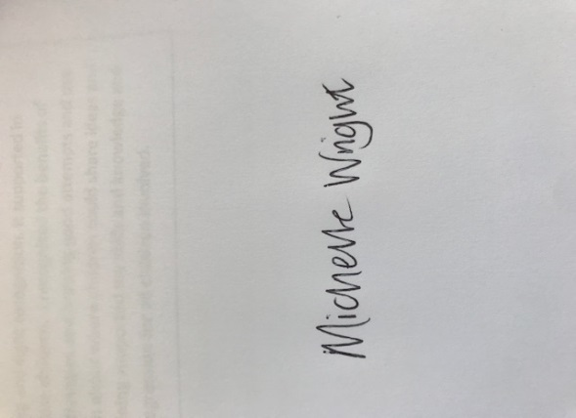

*Michelle Wright*

*Headteacher*

***Don’t forget to follow us on twitter for all the latest news and pictures***

*[](http://www.ywcacassclay.org/)*

[](http://www.google.co.uk/imgres?q=facebook&safe=active&hl=en&biw=1440&bih=731&tbm=isch&tbnid=MpGpuTykj1Ip3M:&imgrefurl=http://www.alvaacademy.clacks.sch.uk/&docid=q3H5bYdE6Tc9bM&imgurl=http://www.alvaacademy.clacks.sch.uk/images/FacebookLogo.png&w=1788&h=594&ei=FKipUtaAOsGjhgfvjoCABA&zoom=1&ved=1t:3588,r:21,s:0,i:156)***- @stcatherinespri - St Catherine’s Primary School Glasgow***