**St Catherine’s Primary School **

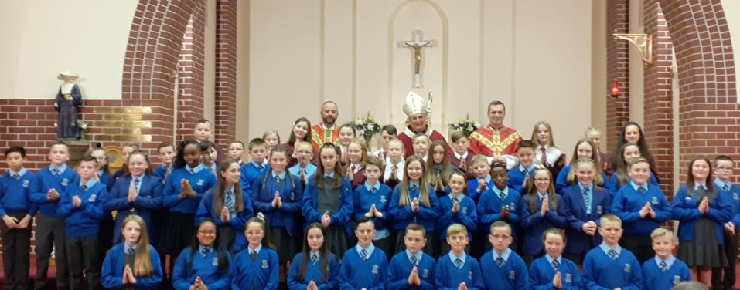

**October Newsletter**

Dear Parents/Carers,

I hope you all have had a very enjoyable break. It has been a very quick and busy Term 1 in St Catherine’s and we are looking forward to all the wonderful things Term 2 will bring.

**Dates for your Diary**

*If parents and carers are invited along to a school event, it will state ‘Parents invited’ next to the event.*

***October***

21st – Back to school

29th – Masterchef Chef to work with P6/5

30th – Halloween Disco – More information to follow

31st – Halloween Event in school – More information to follow

***Safety of our children***  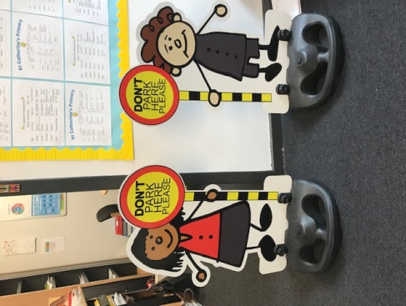

We have now introduced our new zones. These are making a big difference at the end of the school day in ensuring the pavements around the Senior Exits are clear for all pedestrians. Thank you for your help and support in making this effective for all our community.

Please be mindful as the dark mornings are coming in now that you do not drop off on the Zig Zags and please do not turn your car in the road outside the school.

**OUR SCHOOL IS A NO SMOKING AND NO VAPING AREA. Please support us in looking after all our**

**children’s health .**

**Can I also remind you that all parents and carers must only enter the school building through the front door and report in to the reception. This is to comply with our Child Protection Policy.**

***If you are collecting or dropping off a P1 child please note that in relation to Child Protection Policy you must not enter the school toilet with your child.***

**Eco Award **

We are working towards becoming an Eco school and renewing our accreditation. The children have been harvesting vegetables and making their own soup. They have been involved in Litter picking in the school and all classes have taken part in the design an Eco Code competition. Congratulations to P1c they designed the winning Eco Code.

**P7 Confirmations **

We are very proud of our P7 children who were the very first in the Archdiocese for this year to celebrate the Sacrament of Confirmation with Archbishop Tartaglia in St Catherine’s. Everyone who attended on the night commented on what a credit they were to our school.

**Community Links** 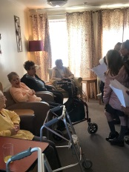

Some of our upper school classes have been visiting Northgate Care home over the last few weeks. The children have taken part in some planting of bulbs and also the BBC Big Music event. We are delighted to support and work with members of our school community. Projects like these also help our children develop skills they require for the future as they engage with the wold of work outside of school.

Maths Week Scotland

We had a busy time in class for Maths Week Scotland. The children were involved in lots of practical, real life problem solving using their maths skills. PE and Art lessons were linked to Maths. Thanks to Parents who came along to the Numeracy Hub for a session with Ms Devlin.

*If you wish to contact me about anything in this newsletter please don’t hesitate to get in touch.*

*Best Wishes*,

*Mrs Michelle Wright*

*Headteacher*

*[](http://www.ywcacassclay.org/)****Don’t forget to follow us on twitter for all the latest news and pictures***

[](http://www.google.co.uk/imgres?q=facebook&safe=active&hl=en&biw=1440&bih=731&tbm=isch&tbnid=MpGpuTykj1Ip3M:&imgrefurl=http://www.alvaacademy.clacks.sch.uk/&docid=q3H5bYdE6Tc9bM&imgurl=http://www.alvaacademy.clacks.sch.uk/images/FacebookLogo.png&w=1788&h=594&ei=FKipUtaAOsGjhgfvjoCABA&zoom=1&ved=1t:3588,r:21,s:0,i:156)***- @stcatherinespri - St Catherine’s Primary School Glasgow***