First Steps to Reading

READING STORIES TOGETHER
Read the story straight through. Occasionally you can make a comment like, “I wonder what will happen next?” or “Oh, no! Look what the naughty puppy has done!”
Sometimes you can run your finger underneath the line of print. This helps your child realise that the words you are saying are the ones on the page.

Occasionally you can say, “Turn to the next page. I’ve finished reading all the words on this page.” This helps your child realise how we go about the process of reading.
If you have time, re-read the story, stopping frequently to discuss both the story and the pictures with your child.

Let you child talk about the story and make the connections between the story in the book and his/her own experiences, for example, “Wouldn’t it be funny if we had a magic car like that!”

Ask your child questions about the story. These questions are not intended as tests but to encourage your child to understand what is going on in the story. Don’t forget to let your child ask you questions too.

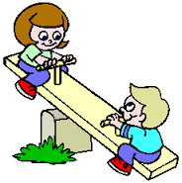
When you have finished the story, encourage your child to talk about the story and to look back carefully at the illustrations.
Always remember to praise your child.

READING STORYWORLD SEE-SAW BOOKS
These books are designed to be read by you and your child together. You read the left-hand page and help your child to read the words in the speech bubble on the right-hand page.
Encourage your child to point with a finger at each word in turn in the speech bubble, as you read the words together. If your child cannot read a word, tell him/her what it says and then read the whole sentence again.
After two pages, encourage your child to read the words in the speech bubble without your help.

Reading Together

READING STORIES TOGETHER
Look at the cover of the book before reading the story and help your child to guess what might be in the story.

Ask your child to turn the page after you have finished reading it.

Ask your child what he/she thinks will happen next in the story, before you turn to the next page.

Re-tell the story together if you have time. It is not important to remember the exact words, but encourage your child to remember events of the story in order.
When you have finished the story, talk about any favourite bits.
Ask your child to guess what happens at the end of the story, just before you turn the last page.

Encourage your child to talk about the story and look carefully at the illustrations.
If you have time, re-read the story and encourage your child to talk about the story and look carefully at the illustrations.

Always remember to praise your child.
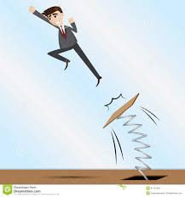

READING STORYWORLD SPRINGBOARD BOOKS
These books are designed to be read by you and your child together. You read the first page of the story and then help your child to read the rest of the story.
Encourage your child to point to each word as he/she reads it. Your child may want to read it alone, or ask to read it with you. If your child cannot read a word, tell him/her what it says and then read the whole sentence again.

