St. Catherine’s Primary School
Home Learning
Class: P1f Teacher: Mrs Farrington
Numeracy/Maths 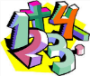 Group 3
Write numbers 0-10 in your jotter. Work hard on correct formation.  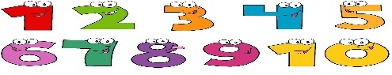 | Ask an adult to listen to you reciting forwards to 10. | Ask an adult to listen to you reciting backwards from 10 to 0. | 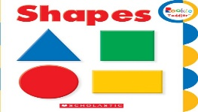  Go on a 2D shape hunt. Can you find items at home that are squares, rectangles, triangles or circles?
Ask an adult to quiz you on sequencing numerals up to 10.  e.g. what number comes before or after 6 and in between 8 and 10. | Find 8 objects in your house. Can you sort them into different groups based on different criteria? e.g. big items and small items or soft and hard items etc. | Talk about the properties of 2D shapes with an adult.  E.g. how many corners and sides does each shape have? | 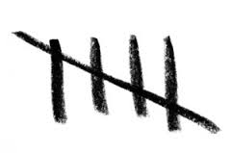  Can you write your numbers to 5 as tally marks?
Practise drawing 2D shapes in your jotter. Can you name them all? | What day is it today? Can you name all the days of the week in order? Use your days of the week song to help you. | Use a clock at home to tell the time (o’clock). Click on the link to practise telling o’clock times.  Hip-Hop Around the Clock | Learn How to Tell Time | Jack Hartmann - YouTube | Count how many steps it takes to walk from your front door to the couch. How many steps does it take to get from the bathroom to the kitchen? Remember only to say then next number when you put a foot down. The number you stop on is number of steps in your count.

