**St Catherine’s Primary School** 

**Home Learning**

**Literacy  Class** P4  **Teacher** Miss Furlong & Miss Stevenson

|  |  |  |  |
| --- | --- | --- | --- |
| **Handwriting.**  Try to do at least 10 minutes handwriting every day. Practise forming 1 group of letters each time. (Letter formation sheets attached on the next page.)  Weekly handwriting will also be uploaded. | Writing  What is your favourite story and why?  Write a summary of the story and explain why it’s your favourite. | Writing  Write your own version of the story with a different beginning, middle or end. Eg. Jack digs a magical tunnel instead of growing a beanstalk.  Be as creative as you can. You can illustrate your story too. | Writing  Uplevel these sentences;   * The pig is in the muck * A cat sat * The boy smiled * The children played * A dog barked |
| C:\Users\NS6885B\AppData\Local\Microsoft\Windows\Temporary Internet Files\Content.IE5\E48DWB3E\blockpage[1].gifC:\Users\NS6885B\AppData\Local\Microsoft\Windows\Temporary Internet Files\Content.IE5\XMO2IJ7D\blockpage[1].gifWriting  Write a creative story based on this picture. Include as much detail as you can by adding adjectives and adverbs. | Writing  Write a biography about someone in your family. Start by asking them questions about themselves to get the information then record it in your jotter. | Before Reading  Answer these questions in your jotter.   * What is the title? What does that tell you about the story? * Is the book fiction or non fiction? How do you know? * What do you predict will happen? Why? * Do you think you will enjoy this book? Why/ Why not? | |
| During Reading  Scan for any unknown words. Use a dictionary or the words around it to work out the meaning.  Record the word and definition in your jotter. | During Reading  Try to read for at least 10 minutes a day. Use expression whilst reading aloud.  Record yourself reading and upload it to SeeSaw once a week if you can. | After Reading  Take a photo or draw your favourite part of the book. Write this part in your own words and explain why it’s your favourite. | After Reading  Create a summary of the book.  You can write a paragraph, record a short clip, draw a comic strip or come up with your own idea. |

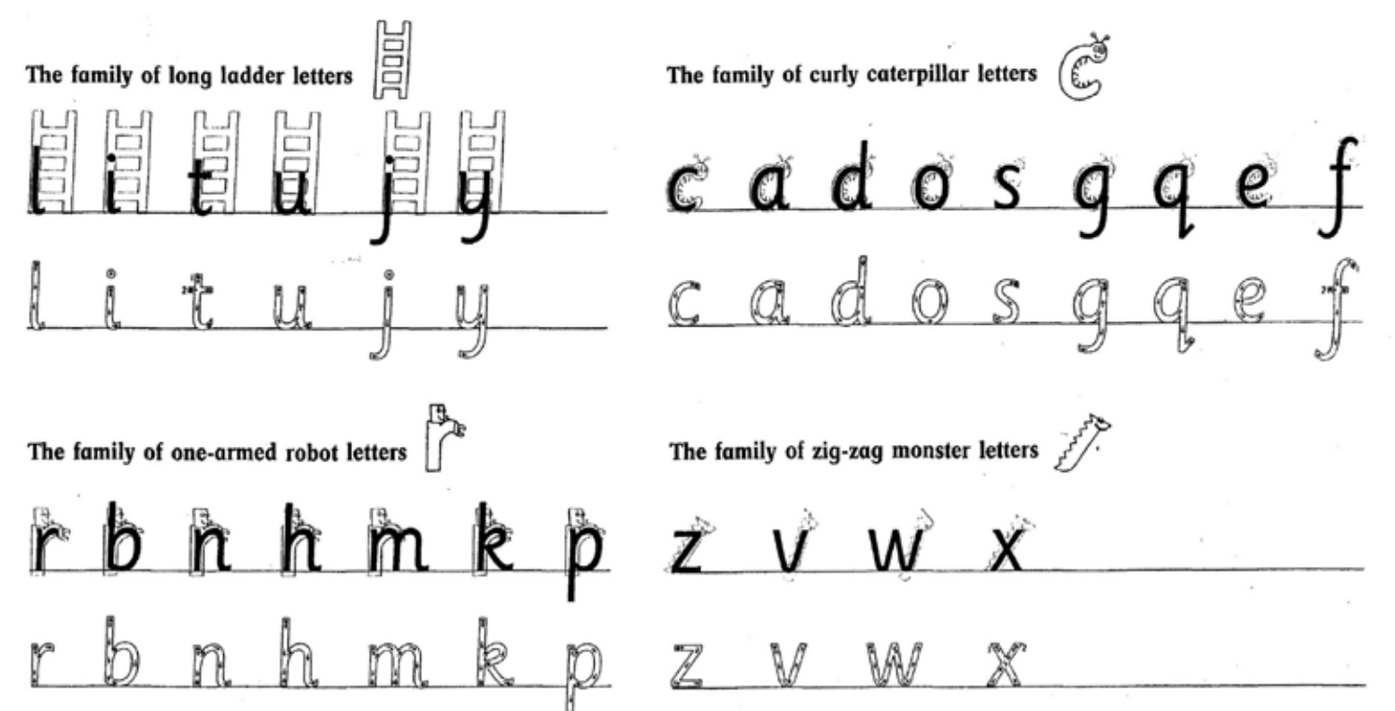

**St Catherine’s Primary School** 

**Maths  Class P4 Teacher Miss Furlong & Miss Stevenson**

|  |  |  |  |
| --- | --- | --- | --- |
| Tables  Practise your times tables for at least 10 minutes a day.  Do this by skip counting, learning the multiples, drawing arrays or asking someone to quiz you. | Tables  Go on to [www.topmarks.co.uk](http://www.topmarks.co.uk) to play meteor multiplication and hit the button to help with your times tables. | Colourful Tables  Write out numbers 0 to 100 and circle the 2, 5 and 10 times table stations in different colours. Do you notice any patterns?  *Challenge * Try the same with 2,4 and 8. | Number  Write these numbers in words;  567 356 678 409  1256 1906 2843 3458  *Challenge* Make these numbers 4 or 5 digits by adding a number to the end. |
| Number  Write the value of the underlined digit.  367 457 1987 1265 2345  *Challenge * Create your own 4 or 5 digit numbers and ask someone at home to underline a digit for you. | Number  Ask someone to give you a number between 0 – 100. What number would you need to add to it to make 100?  Example: What do you add to 68 to make 100? 32.  *Challenge* Try with 1000. | Number  How many different2 2 digit numbers can you make from these numbers?  6 8 3 5 1 8  Choose 5 of your numbers and subtract them from 100.  *Challenge*  Try with 3 digits and subtract from 1000. | Number  Choose 10 different 2 digit numbers. Double and half each number.  Example.  **12** Double 12 is 24. Half of 12 is 6. |
| Sumdog  Log in to Sumdog and see how many coins you can earn. Keep your eyes peeled for competitions and tournaments. | Countdown  Visit Nrich Maths: Countdown to play the game and practise your mental maths agility. | Daily 10  Visit the Top Marks website or download the Top Marks App. Play’ The Daily 10’ and choose the topic you wish to practise | Daily Rigour  Visit the Daily Rigour website. Can you complete any of the problem solving tasks in the maths **first level** newspaper? |

**St Catherine’s Primary School** 

**Home Learning**

**IDL (Topic)  Class: P4 Teacher: Miss Furlong & Miss Stevenson**

|  |  |  |  |
| --- | --- | --- | --- |
| **Pick a country of your choice.**  *(If you’ve already researched a country choose another in a different continent.)* | Your task is to research this country and create a fact file about it for others to read and learn from.  If researching independently always include ‘for kids’ after each search. | Create a front cover and contents page. | What continent is your country in?  Look at it on a map.  Which other countries does it border? |
| Draw a map of your country highlighting where the capital is and any other main cities. | Which language do they speak there?  Can you learn any common phrases like hello or thank you? | What is the culture like? Are there any special traditions/ holidays? | What does the flag look like? |
| What is the climate like in your country? Compare it to Scotland. | What animals do you find here?  It is different from Scotland? | Did you find out any other interesting facts about your country?  Include them in your factfile. | Share your fact file with someone at home and on Seesaw if you can. |

**St Catherine’s Primary School** 

** Home Learning**

**Health and Wellbeing Class P4 Teacher Miss Furlong & Miss Stevenson**

|  |  |  |  |
| --- | --- | --- | --- |
| Draw a self-portrait and surround it with things you achieved/ learned in 2020.  Example:  I learned to tie my shoe laces.  I can count in 2’s to 40. | Happy New Year. It is 2021.  Complete the following sentences for this coming year.  I will make ________.  I will learn_________.  I will try__________.  I will give _________.  I will share __________. | Active:  How many different ways can you be active while indoors?  Example: Sit on a chair and stand / stretch up. Repeat multiple times.  Challenge: Can you create a workout for yourself using your ideas? | Time to get active. (You can share these on Seesaw.)  Some options:  Joe Wicks live at 9am Monday, Wednesday and Friday.  Search ‘Just Dance for Kids’ on YouTube and choose a routine.  Create your own activity. |
| Create a healthy snack for yourself or someone at home.  (You can share an image on Seesaw.) | Find Your Brave.  Watch the video attached or type in ‘the greatest showman this is me with keala settle 20th century fox’ to YouTube.  https://www.youtube.com/watch?v=XLFEvHWD_NE   * How is she brave in this video? * What is the difference between the start of the video and the end? | Time to get creative.  Create your own game. This could be without resources or with resources such as paper and pencils.  Play your game with someone at home.  (You can share your game on Seesaw.) | Connect with others.  Ask and adult at home if you can call/ facetime a relative or someone you miss.  You could draw a picture before the call to show them. |
| Acts of Kindness.  Can you complete 3 or more random acts of kindness?  Example: helping to put the dishes away without being asked. | Sit down with someone at home and have a chat. This could be about anything sport, the weather, how you’re feeling etc. | Cosmic Yoga.  Complete a cosmic yoga session of your choice on YouTube.  You could get someone else in your home involved too. | Read a story independently or ask someone at home to read you a story for enjoyment. |

**St Catherine’s Primary School** 

**Home Learning**

**RERC Class Primary 4 Teacher Miss Furlong & Miss Stevenson**

|  |  |  |  |
| --- | --- | --- | --- |
| Caring for others:  As Christians and followers of Jesus Christ we have an obligation to follow the example of Jesus by showing care for the world and for the needs of others. Discuss different ways that your teacher, headteacher and priest look after the needs of others. | Show care for others by helping out at home for example, tidy your room or play with a sibling. | Research St Vincent de Paul.  Who is he? What was good about the way Saint Vincent de Paul lived his life? What could you do in your life to follow his example? | Illustrate St Vincent de Paul.  Create a list of 5 things you could do, such as being kind, to live your life like St Vincent de Paul. |
| Look up the Gloria prayer.  Read the prayer.  Discuss the meaning of it with someone at home. | Pick one of the following saints and read a passage about them to recognise how Saint’s listen to God’s Word.  --St Columba (Matthew 28: 16-20)  --St Francis of Assisi (Mark 8: 1-4) | Revisit the Our Father and the Hail Mary. Use your prayer books or alternatively look up the words online.  Say them out loud to someone at home or record yourself on seesaw and upload it. | St Catherine is the patron saint of our school.  From what you learned in class, can you remember any information about her?  Tell someone at home some information about her. |
| Using the link below, watch the video to find out about Pentecost. (Alternatively, type in ‘Animated Bible Stories- Pentecost for kids’ to YouTube)  https://www.youtube.com/watch?v=KwJJJoSGw84 | Create an image which shows the events of Pentecost. | Pray for those who are in need or anyone you know that needs a prayer at this time. | Revisit the Glory Be, Grace Before and After meals.  Use your prayer books or alternatively look up the words online.  Say them out loud to someone at home or record yourself on seesaw and upload it. |