

**St Catherine’s Primary School**



**School Handbook**

  **St Catherine’s Primary School**

Dear Parent/Carer,

On behalf of the staff and pupils of St. Catherine’s Primary, I am delighted to welcome and you and present to you our School Handbook for 2020/2021.

This handbook contains a range of information that I hope you find helpful in giving you an insight into how the school is organised. Please do not hesitate to contact the school or check the school website if you need more information.

In St. Catherine’s Primary we encourage everyone to be the best they can be.

It is our belief that the school is an integral part of the community and by creating a very welcoming environment, working in partnership with carers, the Parish and the wider community we will achieve successful outcomes.

I look forward to having you and your child work with us and hope that this will be the start of a strong partnership.

Yours sincerely,

Michelle Wright

Head Teacher

***Our Vision Statement for St Catherine’s***

*Our vision for St Catherine’s Primary is to have a community who feel happy, confident and proud of who they are. Through following and listening to God, we want to give everyone the opportunity to be all they can be to reach their full potential in life.*

*We will have high expectations for all and will strive to prepare our children for work and life in a global community. This will be achieved by providing a safe and nurturing environment where everyone feels respected and valued through our strong Catholic Ethos*.

***Our School Values***

***Love***

***Respect***

***Inclusion***

***Trust***

***Kindness***



***Every child matters, Every moment counts***

**School Information**

**Name**

St Catherine’s Primary School

**Address**

274 Rye Road

Glasgow

G21 3JR

**Telephone Number**

0141 558 8582

**Email**

headteacher@st-catherines-pri.glasgow.sch.uk

**Background information**:

* Co-educational school
* Denominational
* Stages taught: P1-P7
* Current Roll: 382
* Planning Capacity: 528
* Learning Community: All Saints

**Organisation of Classes**

The following guidelines set by Scottish Government apply.

P1 maximum 25

P2&3 maximum 30

P4-7 maximum 33

Composite classes maximum 25

Composite classes have pupils from more than one stage.

**The School Day**

Our school day begins at 9.00am and ends at 3.00pm.

Morning Interval 10.30am - 10.45am

Lunch 12.15pm - 13.00pm

P1 children are dismissed at lunchtime until the first Monday in September after which they will remain in school until 3.00pm.



**Meet our Team!**

**Senior Leadership Team**

Head Teacher: Mrs Michelle Wright

Depute P1-P4: Miss Claire Reynolds

Depute P5-P7: Miss Michelle McShane

Principal Teacher: Mrs Jennifer Anderson

Principal Teacher : Mr David Paton

**Teaching Staff**

P1b Miss Natalie Brogan

P1f Mrs Heather Farrington

P1m Mrs Donna Molloy

P2d Mrs Marianne McDougall

P2c Mrs Leah McConnell

P3m Ms Helen MacInnes

P3g Miss Margo Gillooly

P4f Miss Emma Furlong

P4s Miss Nicola Stevenson

P5l Miss Claire Luedke

P5r Miss Miriam Reynolds

P6h Mrs Maria Hewitt

P6s Miss Alana Stewart

P7v Mrs Natalie McVey

P7d Miss Shannon McDaid

NCCT Miss Emma Owens

CLOL. Ms Lorraine Devlin

Nurture Teacher Mrs Clair Duncan

Inclusion Teacher Mrs Claire McArthur

**Support for Learning Workers**

Miss Jane Ashford

Miss Roseanne Griffin

Mrs Catherine Henderson

Miss Donna McFarlane

Miss Alex Smith

Mrs Isobel Stewart

Mrs Roberta Turner

Miss Charlene Tracey

Mrs Jacqueline Robb

Mrs Alison Haldane

Miss Shelley Lyle

**Janitor**

Mr Bob Reynolds

**Clerical Assistant**

Mrs Angela McGuinness

Ms Laura Henderson

**Enrolment**

Registration of Primary 1 children takes place in November and is advertised widely in local press etc. Prospective parents are welcome to visit the school and should contact the school office. Enrol is now conducted online – see the link below.

Families living outwith the catchment area are welcome to make a placing request to attend Glasgow Primary School but must enrol their child online as a first step**.** Further information is available using the following:

**<https://www.glasgow.gov.uk/index.aspx?articleid=18426>**

**School Holidays**

Details of holiday dates are available on the Glasgow City Council website: [**https://www.glasgow.gov.uk/index.aspx?articleid=17024**](https://www.glasgow.gov.uk/index.aspx?articleid=17024)

**Pupil Absence**

Within St. Catherine’s Primary School good attendance is encouraged at all times. Parents are asked to advise if their child is going to be absent. This should be done before 9.30am on the first day of absence. If the child is going to be absent for some time, it would be helpful to know at the earliest opportunity. The school uses daily text messaging to inform parents and carers of absence if no contact is made. All unexplained absence is investigated by the school and appropriate action taken. All calls must be made to the Pupil Absence Reporting Line on 0141 287 0039. The line is open between 08.00-15.30 Monday to Friday. Alternatively you can use the online form on the Glasgow City Council website: [**https://www.glasgow.gov.uk/index.aspx?articleid=18832**](https://www.glasgow.gov.uk/index.aspx?articleid=18832)

**Medical & Healthcare**

The school nurse visits at various times during the year for routine health checks, vaccinations and medical examinations. Parents are kept informed by letter. All pupils are entitled to receive the flu vaccination before the end of the calendar year. Parents are informed in advance of this.

If a child becomes ill during the course of the school day, he/she may require to be sent home. Please ensure that you keep the school informed of all contact details.

Parents should inform the school of any medical requirements relating to their child. If a child requires medication during the school day, parents must complete the appropriate medical form. This is available on request from the school office. Parents must ensure that medical details are up to date, particularly allergies. If a child requires medication, it is the parents responsibility to ensure this is in date and renewed annually. Please also ensure that all emergency and contact details are up to date at all times,

**Emergencies**

We make every effort to maintain a full educational service, but on some occasions circumstances arise which lead to disruption. Schools may be affected by, for example, severe weather, temporary interruption of transport, power failures or difficulties of fuel supply.

In such cases, we shall do all we can to let you know about the details of our closure or re-opening by using letters, texts and the local media etc.

**School Uniform**

The school uniform is:

* Blazers with school badge
* Outdoor jacket with school badge
* Blue jumper/cardigan with school badge
* Blue shirt
* School tie
* Grey skirt/trousers
* Blue polo shirt for Physical education lessons
* Black shoes for every day wear
* Soft black shoes for indoor use, e.g. Physical Education lessons

Sweatshirts, cardigans, polo shirts and ties with the school logo are available for purchase from Trutex in Glasgow City Centre.

It is expected that all children attending St Catherine’s Primary School will adhere to this dress code.

**PE Kit**

It is important that pupils come prepared to learn and for PE this requires appropriate clothing. All jewellery should be removed. Pupils who are not participating in PE must have a note or a medical certificate. Pupils who are unable to participate in practical PE should still bring their kit to allow them to assist in the lesson by refereeing, keeping scores or assisting with the distribution of equipment. This ensures that they are still able to take part in some way in the work of the class and do not miss out on the knowledge and understanding of the course.

There are forms of dress that are unacceptable in school, such as items of clothing which:

* Potentially encourage factions (such as football colours)
* Could cause offence (such as anti-religious symbolism or political slogans)
* Could cause health and safety difficulties (such as loose fitting clothing, jewellery)
* Could be used to inflict damage on other pupils

**Clothing & Footwear Grants**

Parents/Carers receiving Income Support, Job Seekers Allowance (Income Based), Working Tax Credit (with a total annual income of less than £15,860*), Housing Benefit, Council Tax Benefit or Universal Credit (where the total income is less than £7320) will normally be entitled to monetary grants for footwear and clothing for their children. Information and application forms may be obtained from schools and at

**<https://www.glasgow.gov.uk/index.aspx?articleid=17885>**

**School meals**

Our school provides a lunch service which offers a variety of meals and snacks.  Medical diets for children can be provided.  Further information can be found here: [**http://www.fuelzoneprimary.co.uk/UserFiles/files/Medical_Diet_Leaflet%20-%20June%202017%20WEB.pdf**](http://www.fuelzoneprimary.co.uk/UserFiles/files/Medical_Diet_Leaflet%20-%20June%202017%20WEB.pdf)**.**

***Please inform the Head Teacher.***

Children who prefer to bring packed lunches will be accommodated in a suitable area.

All children in P1-3 are entitled to a free school meal.

If you plan to send your child/children to breakfast club, you should inform the staff of any medical dietary requirements.

Children and young people of parents/carers receiving Income Support, income-based Job Seekers Allowance, Working Tax Credit (where income is less than £7920*), Child Tax Credit only (where income is less than £16,500*), Universal Credit (where income is less than £7,320) and income-related Employment and Support Allowance are entitled to a free midday meal. Information and application forms for free school meals may be obtained at

[**https://www.glasgow.gov.uk/index.aspx?articleid=17885**](https://www.glasgow.gov.uk/index.aspx?articleid=17885)

**Transport**

The education authority has a policy of providing free transport to all pupils who live outwith a certain radius from their local school by the recognised shortest walking route. This means that the provision of transport could be reviewed at any time. Parents/Carers who consider they are eligible can apply online at

**<https://www.glasgow.gov.uk/index.aspx?articleid=17882>**

**Transfer from Primary to Secondary School**

Children and young people normally transfer between the ages of 11 ½ and 12 ½, so that they will have the opportunity to complete at least 4 years of secondary education. Parents and carers will be informed of the school arrangements no later than December of P7. Children from our school normally transfer to:

All Saints Secondary School

299 Ryehill Rd

Glasgow

G21 3EN

All Saints Secondary School staff work with our pupils from Primary 7 onward to prepare them for the transfer to secondary school.

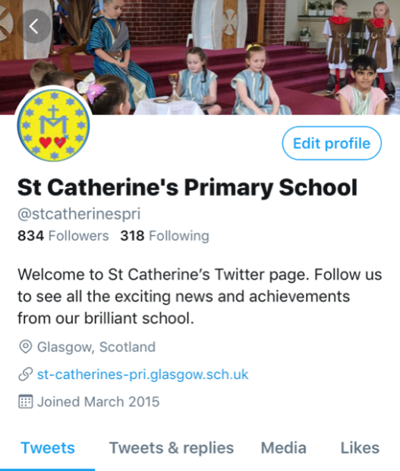**Communication with Parents**

At St Catherine’s Primary School we use a variety of ways to keep in touch.

*Open Door Policy* – the Senior Leadership Team are available for all parents and carers at any time providing they are not teaching or in another meeting. Please phone to make an appointment.

*School Newsletters* – will be sent out on a regular basis to keep parents informed about the work of the school.

*Class Newlsetters* – will be sent out termly by class teachers to keep parents/carers informed of curricular updates.

*Letters* – further information which requires a response may be sent out in letter form.

*School website/Twitter* – will contain a great deal of information about the school. It is a good idea to check this regularly.

*Text messaging* – You may also receive text reminders about events/school closures etc.

*Meetings* - Parents and carers are welcome in the school to discuss any aspect of their child’s development and progress. To avoid disappointment, it is advisable to make an appointment. There are various opportunities throughout the year when parents can discuss their child’s progress with the class teacher and view the child’s work.

Parents and carers are welcome at other events throughout the school year e.g. workshops, information evenings, class performances, religious and other assemblies. The school newsletter and website will keep you informed.

**Emergency Contact Information**

At the start of each school session, parents will be issued with the annual data check form. Please ensure that this is completed and returned to the school. It is also important that you let us know if there are changes to your telephone number(s) or to those of your emergency contacts throughout the year.

**Data Protection – use of information about children and parents/carers**

We collect information about children attending school (and also about parents/carers, emergency contacts etc. provided in the annual data check) to allow us to carry out the Council’s functions as the education authority for the City of Glasgow. This may sometimes involve releasing personal information to other agencies and other parts of the Council, particularly in relation to child protection issues or criminal investigations, and it may also be used for research purposes (see the link below for more details regarding this).

Information held by the school is, in legal terms, processed by Glasgow City Council. The Council is registered as a data controller under the Data Protection Act 2018 and all personal data is treated as confidential and used only in accordance with the Data Protection Act, the General Data Protection Regulations, and the Information Use and Privacy Policy approved by the City Council. For more information on how we use personal information, or to see a copy of the Information Use and Privacy Policy, see [**https://www.glasgow.gov.uk/index.aspx?articleid=18010**](https://www.glasgow.gov.uk/index.aspx?articleid=18010) **.**

Education specific privacy statements can be accessed at [**https://www.glasgow.gov.uk/index.aspx?articleid=22069**](https://www.glasgow.gov.uk/index.aspx?articleid=22069) **.**

**Appointments during school hours**

If your child has an unavoidable appointment, please advise the school office and provide a copy of the appointment letter which will be photocopied and recorded within the school office.

**Comments & Complaints**

In St Catherine’s Primary School we aim to have positive relationships across our school community. However, if you have a comment or complaint about any aspect of school life, please contact the Head Teacher in the first instance.

Glasgow City Council complaints procedures are available using the following link: [**https://www.glasgow.gov.uk/index.aspx?articleid=16133**](https://www.glasgow.gov.uk/index.aspx?articleid=16133)

The above website also includes information on data protection and freedom of information.

**Curriculum**

**Curriculum for Excellence 3-18**

Curriculum for Excellence has been introduced to raise standards of learning and teaching for all 3 to 18 year olds. It aims to help prepare children and young people with the knowledge and skills they need in a fast changing world. As part of Curriculum for Excellence all children from pre-school to the end of S3 will receive a rounded education known as a Broad General Education(BGE). Curriculum for Excellence is all about bringing real life into the classroom and taking lessons beyond it.

Through the experiences we provide at Glasgow Primary School we want our children to become Successful Learners, Confident Individuals, Responsible Citizens and Effective Contributors. We are committed to providing children with a broad general education and focus on eight curriculum areas.

|  |  |  |  |
| --- | --- | --- | --- |
| Expressive Arts | Health & Wellbeing | Languages | Mathematics |
| Religious & Moral | Sciences | Social Studies | Technologies |

Progress in learning is indicated through curriculum levels as detailed below.

|  |  |
| --- | --- |
| **Level** | **Stage** |
| Early | The pre-school years and P1 or later |
| First | To the end of P4, but earlier or later for some |
| Second | To the end of P7, but earlier or later for some |
| Third & Fourth | S1-S3, but earlier for some |



**Expressive arts:** The inspiration and power of the arts play a vital role in enabling our children and young people to enhance their creative talent and develop their artistic skills.

**Health and wellbeing:** Learning in health and wellbeing ensures that children and young people develop the knowledge, understanding and skills which they need now and in the future to help them with their physical, emotional and social wellbeing.

**Science:** Science and its practical application in healthcare and industry is central to our economic future, for our health and wellbeing as individuals and as a society.

**Social Studies:** Through social studies, children and young people develop their understanding of the world by learning about other people and places both past and present, societies, their beliefs and values.

**Religious and moral education:** Religious and moral education includes learning about Christianity and other world religions, and supports the development of beliefs and values.

**Languages:** Knowing other languages and understanding other cultures is a 21st century skill set for students as they prepare to live and work in a global society.

**Mathematics:** Mathematics equips us with the skills we need to interpret and analyse information, simplify and solve problems, assess risk and make informed decisions.

**Technologies:** The range of subjects in technical education has changed significantly over the last two decades and now includes craft, design, engineering and graphics.

There will be opportunities throughout the year for parents and carers to learn more about aspects of the curriculum and to be consulted about significant changes if appropriate.

**Useful websites**

[**www.curriculumforexcellencescotland.gov.uk**](http://www.curriculumforexcellencescotland.gov.uk)

[**www.educationscotland.gov.uk/parentzone/index.asp**](http://www.educationscotland.gov.uk/parentzone/index.asp)

**Religious Observance**

St Catherine’s Primary is a Roman Catholic School. Our religious beliefs permeate all aspects of our curriculum and are the foundation for our positive, Christian ethos that is based on Gospel Values.

We have very positive and active links with the parish of St Catherine’s and the school is well supported by the clergy. Whole school Masses and assemblies are celebrated regularly, with everyone being welcome to attend.

In accordance with direction from The Archdiocese of Glasgow we implement ‘This is Our Faith’, a Programme of Study for Religious Education in Catholic Schools devised in response to the development of Curriculum for Excellence. Through this programme we aim to develop a love and understanding of our Faith, prepare children for the Sacraments of Reconciliation, Holy Communion

and Confirmation and develop knowledge and understanding of other World Religions. God’s Loving Plan Education Programme produced by the Archdiocese of Glasgow is taught across the school. Parents of Primary 7 pupils are invited to an information meeting prior to the programme being delivered at this stage.

**Assessment & Reporting**

We operate a policy of continuous assessment in St Catherine’s Primary School. All children are assessed both formally and informally throughout the year. This enables us to build a clear picture of each child’s ongoing progress. Assessment is a tool used by teachers to plan and prepare programmes of study that challenge and extend pupils knowledge, understanding and skills. It also enables staff to evaluate the effectiveness of teaching methods and resources. A variety of assessment methods are used to enable staff to pass on information to parents about the progress of their child. Assessment records are kept by the class teacher and form the basis of discussion at Parents’ Evenings in November and March. An annual report is sent to parents towards the end of each school year.

St Catherine’s Primary School is embedding ‘Assessment is for Learning’ strategies that involve pupils assessing their own work. All pupils engage in identifying personal targets which support them in their next steps along their learning journey. Staff have the opportunity through tracking meetings to discuss pupil progress with SLT.

**Support for Pupils**

The school has a duty to ensure that all pupils have equal access to the curriculum, with appropriate support for their needs if required. This applies to the content of lessons, teaching strategies and minor adaptations to the school environment. There are a wide range of factors which may act as a barrier to learning. We are committed to working closely with parents and carers to ensure that they are fully involved in any decisions about support for their children’s needs.

At St Catherine’s Primary School, we strive to meet the needs of all our pupils through the Principles and Practices of GIRFEC (Getting in Right for Every Child). GIRFEC ensures we look at the needs of all our children by focusing on the well-being indicators. More information can be found about GIRFEC by clicking on the following link:

[**https://www.glasgow.gov.uk/index.aspx?articleid=10487**](https://www.glasgow.gov.uk/index.aspx?articleid=10487)**.**

The needs of our children may vary throughout the course of the school year or may include longer-term needs. Pupils in our school are supported in their learning by their Class Teachers, who plan and prepare appropriate learning activities for the pupils in their class. If however, a Class Teacher believes a pupil may require additional support, in terms of having difficulty or being more able, they may request additional resources or additional teaching support for the pupil. This could be provided

within the school by using different resources, Support Assistant time, or perhaps time with another member of teaching staff, either in a small group or on a one to one basis.

Further information relating to additional support needs is available on the Glasgow City Council website at [**https://www.glasgow.gov.uk/index.aspx?articleid=18941**](https://www.glasgow.gov.uk/index.aspx?articleid=18941)

Information on the Glasgow City Councils’ Parental Involvement Strategy can also be found at [**https://www.glasgow.gov.uk/index.aspx?articleid=17870**](https://www.glasgow.gov.uk/index.aspx?articleid=17870)

**Getting it Right for Every Child**

GIRFEC isn’t an extra thing people have to do. It’s a way for those who support children to work differently, making sure that they are all on the same page. Where needed, GIRFEC links day-to-day work in education, health, policing, social work and the voluntary sector – in fact any organisation whose staff come into direct contact with children. It makes it easier for those different organisations to communicate consistently with each other, and with parents, carers, children and young people.

GIRFEC provides a structure that helps people to work in the same way and use the same language. This allows discussion with the child and their family to focus on what is good in a child’s life, and what might need attention or support.

It’s the bedrock for all children’s services and can also be sued by practitioners in adult services who work with parents or carers.

The approach helps with practitioners focus on what makes a positive difference for children and young people – and how they can act to deliver these improvements. Getting it right for every child is being threaded through all existing policy, practice, strategy and legislation affecting children, young people and their families.

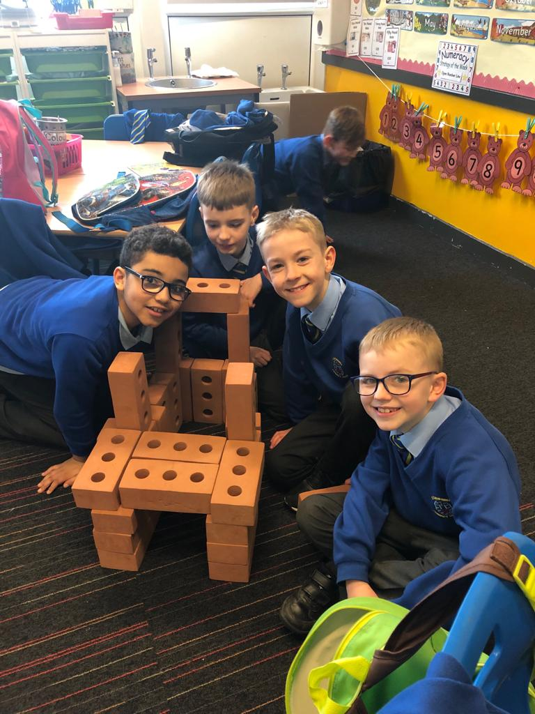

**What Getting it Right for Every Child means:**

**For children, young people and their families:**

* They understand what is happening and why
* They have been listened to carefully and their wishes have been heard and understood
* They will feel confident about the help they are getting
* They are appropriately involved in discussions and decisions that affect them
* They can rely on appropriate help being available as soon as possible
* They will have experienced a more streamlined and co-ordinated response from practitioners

**For practitioners:**

* Putting the child or young person at the centre and developing a shared understanding within and across agencies
* Using common tools, language and processes, considering the child or young person as a whole, and promoting closer working where necessary with other practitioners

**Promoting Positive Behaviour**

We strive to provide a well-ordered, respectful and positive atmosphere in school where Gospel values are promoted. We have high expectations of pupil behaviour and our children respond very well displaying outstanding behaviour. St Catherine’s is recognised locally and beyond for our well behaved children. On the rare occasion that there are serious breaches of discipline the parent/carers of the child are immediately advised. It is extremely important that we have the co-operation from parent/carers with regard to their child’s behaviour and we are fortunate that we have very positive school/parent relationships.

Children’s Rights as outlined in the UNCRC (United Nations Convention on the Rights of the Child) are fundamental to a good school ethos. Adults in our school work with our pupils to ensure they are aware of their rights and fully respect the rights of others. Therefore, the approach within St Catherine’s Primary School is to build a positive ethos that demonstrates care and respect for all. Positive behaviour is recognised and celebrated. Our school operates a system of class charters to set out expected behaviour. This is celebrated through Golden Time treats, Star if the Week and Pupil of the Month assemblies and certificates sent home to parents.

The highest standards of behaviour are expected of pupils at all times. Where this is not the case, a variety of sanctions are used. Parents are asked to co-operate with the school in encouraging a sense of responsibility and good behaviour in their children.

**Home Learning**

In St Catherine’s Primary School, we believe that Home Learning is very important in enabling your child to make steady progress. Home Learning tasks should be a challenging and enjoyable experience for children to share with parents. It is important in relation to home/school partnership.

Parents should supervise homework without completing homework for their child. If possible children should be supported to find a quiet time where they can sit at a table without the television or other distractions. This will enable children to focus on homework and complete tasks to a satisfactory standard. If a child experiences difficulty with work parents should inform the teacher by writing a short note at the bottom of the homework task or in the homework diary. If the child gets something wrong then they should be given the opportunity to try again. Parents should avoid doing the correction for the child.

**Parent Council**

We have an active Parent Council that represents the views of all parents. All parents are welcome to attend Parent Council meetings and can become members at the AGM in September.

A Parent Council could get involved in:

• Supporting the work of the school

• Gathering and representing parents’/carers’ views to the Head Teacher, education authority and Education Scotland

• Promoting contact between the school, parents/carers, children and young people and the local community

• Fundraising

• Involvement in the appointment of senior school staff.

Parent Councils are recognised in law from August 2007. As a statutory body, the Parent Council has the right to information and advice on matters that affect children’s education. So, the school and the local authority must listen to what the Parent Council says and give it a proper response. Every school’s Parent Council will be different because it will be parents/carers in each school who make key decisions. The Parent Council is also entitled to support from the education authority in fulfilling its role.

**Membership of the Parent Council**

Generally, members of the Parent Council must be parents/carers of children and young people who attend the school and the chairperson must have a child in the school. However, the Parent Council can decide to co-opt other members from teachers and the community who will have knowledge and skills to help them.

**Pupil Council**

Our Pupil Council is made up of one representative from Primary 1 to Primary 7. The council members are elected by their classmates to represent them for the year. We consult them on a regular basis e.g. if we are making changes to policies or procedures, this presents children with the opportunity to express the ‘pupil voice’. The Pupil Council plays a crucial role within the school which ensures that the views of pupils are heard.

**Lunchtime and After School Clubs**

We have a wide range of Lunchtime and After School Clubs that run from Monday to Friday to extend learning experiences. Strong links with community organisations and our Active Schools Co-ordinator are vital for the success of these programmes. These currently include:

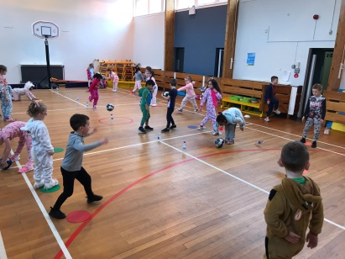

Dance

Basketball

Netball

Athletics

Badminton

Football

Basketball

Multisports

Lunchtime clubs run from 12.15-1pm. After school clubs run from 3-4pm. Please check your child’s school bag for information as places are popular and usually limited.

In addition to Active Schools assisting us in providing us with coaches for lunch time and after school clubs, they provide Primary 6 pupils with Buddy Training. The children are trained in how to teach younger pupils to play structured playground games. After training the Primary 6 pupils play these games in the playground with infant pupils.

**Useful Contacts**

**Parentzone Scotland** is a unique website for parents and carers in Scotland, from early years to beyond school.  The website provides up-to-date information about learning in Scotland, and practical advice and ideas to support children’s learning at home in literacy, numeracy, health and wellbeing and science.  Information is also available on Parentzone Scotland regarding additional support needs, how parents can get involved in their child’s school and education.  Furthermore, the website has details about schools including performance data for school leavers from S4-S6; and links to the national, and local authority and school level data on the achievement of Curriculum for Excellence levels.  Parentzone Scotland can be accessed at:

[**https://education.gov.scot/parentzone**](https://education.gov.scot/parentzone)**.**

**Glasgow City Council**

Education Services

City Chambers East

40 John Street

Glasgow G1 1JL

Tel: 0141 287 2000

[**www.glasgow.gov.uk**](http://www.glasgow.gov.uk)

***Last updated November 2020***