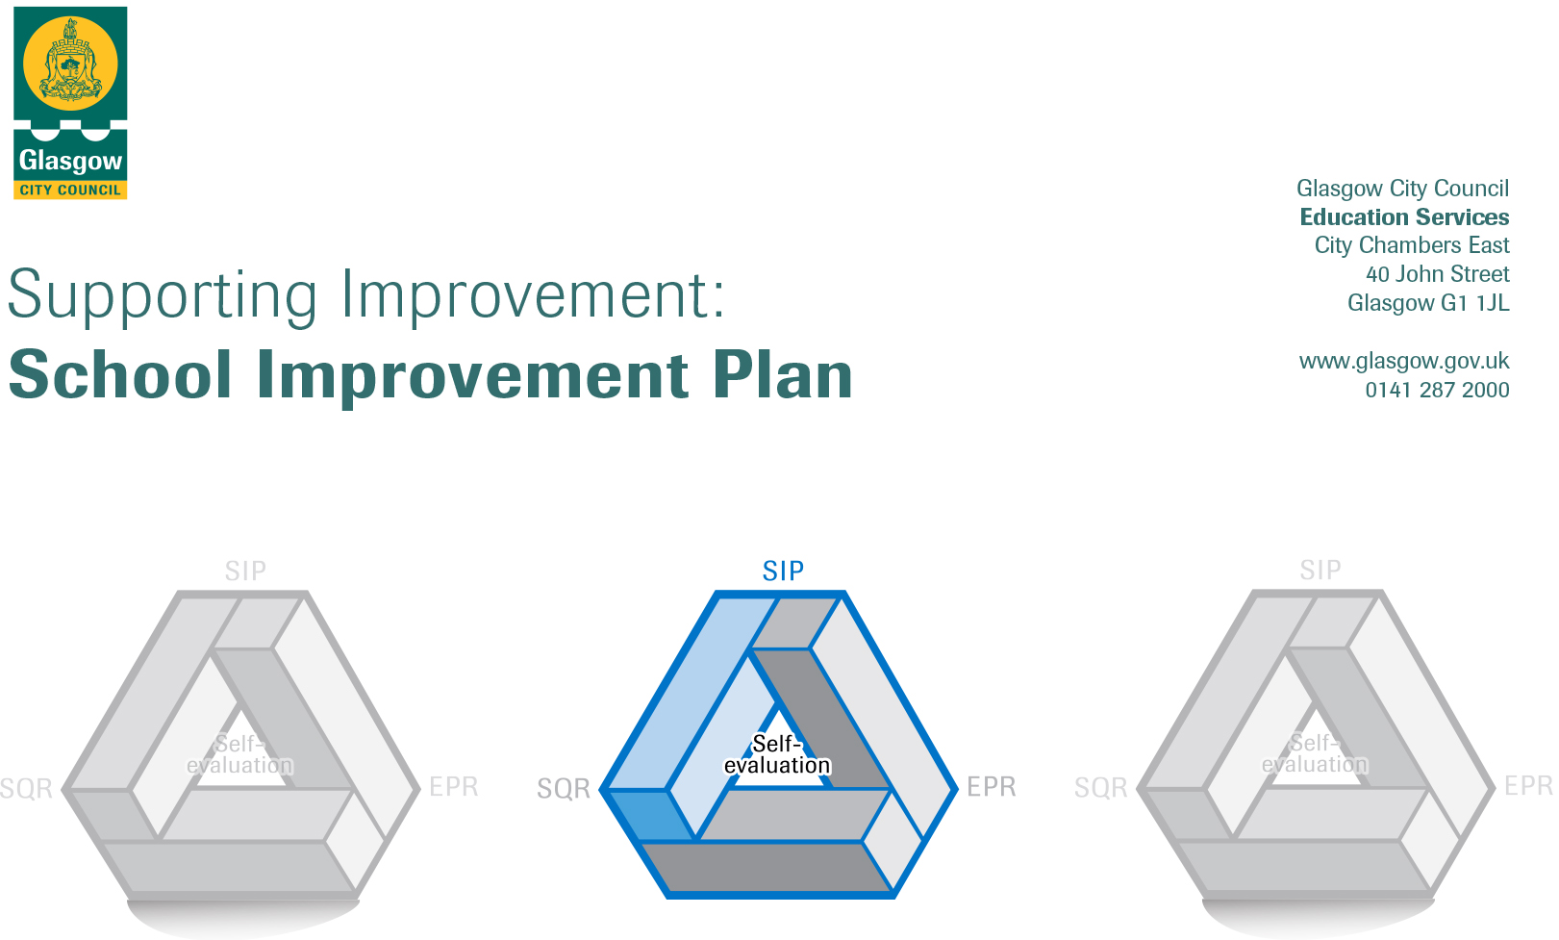

Establishment |  | St Catherine’s Primary School
Head of Establishment |  | Mrs Michelle Wright
Area/Local Improvement Group |  | North East / LIG 1
Head of Service |  | Gerry Lyons
Area Education Officer/  Quality Improvement Officer |  | Andrea Reid

CONTENTS
1. Vision, Values and Aims
2. Summary of Self-Evaluation Process / Priorities for Improvement in the current session
3. Action Planning

Action Plan Summary for Stakeholders

1. Our Vision, Values and Aims
Through the development of Curriculum for Excellence, St Catherine's Primary School will endeavour to deliver the highest quality of education in an organised and caring community based on Gospel Values. Committed to developing the potential of all pupils in an atmosphere of; trust, co-operation and mutual respect, we will strive to ensure that effective learning and teaching will enable pupils to aspire to realise their full potential - spiritually, academically, socially and aesthetically. This will be achieved in fostering effective partnerships between home, school and church.
Our school values are based on the Christian values of the Gospel.
Our Vision, Values and Aims will be revisited this coming session.

2. Summary of our self-evaluation process.
Parents complete evaluations after every school event this allows us to look at ways to improve events and evaluate the success of the event.
Last session we also used online Glow surveys to engage with parents in the self- evaluation process.
This session will be continuing to support teaching staff to engage with the professional standards in the self-evaluation process and to focus on the impact of continuing professional development. We work hard to link the development work in the school and staffs’ individual development needs to give effective PRD opportunities.
We regularly evaluate teaching and learning during SLT observations, peer observations and learning walks.
We regularly evaluate improvements throughout the year with all stakeholders. Support staff have regular involvement in the self-evaluation process, during in-service days.
Strengths identified:
The ethos and culture of our school reflects our commitment to positive relationships, nurture and the values of the Catholic faith. Our school provides an environment in which children feel safe and supported. Our children are keen to learn and when engaged in their learning, they are respectful of each other and of the adults who support their learning.

The introduction of our Play based pedagogy has brought innovative and exciting developments to our P1 Curriculum. It has increased learner engagement with improved opportunities for developing creativity, personalisation and choice .

Our work this year developing numeracy based on the Glasgow Counts model, is enhancing the learning and teaching of numeracy across the school. There are early signs of positive impact through the consistent approach to the teaching of numeracy strategies across all stages. The children are engaged and motivated to use the various strategies. They are developing their skills at self- evaluating as they are allowed to choose which challenge is best for them.

P2 children have been working on the Daily Supported Reading programme. The programme is beginning to impact on learner engagement and pace of progress in reading.

Priorities for development:
1: To raise attainment in Numeracy through Glasgow Counts approach. We are moving onto Year two. Alongside this we will be developing effective learning and teaching strategies and assessment approaches.
2: To raise attainment in Literacy Glasgow’s Literacy For All through approach. We are revisiting Year one. Alongside this we will be developing effective learning and teaching strategies and assessment approaches.
3: To develop effective nurture support and strategies across the school (Incorporating Mindfulness and PATHS training to support pupils and staff)
4: To revise and create Vision, Values and Aims for the school that reflect our culture and ethos

3. Action Planning

No. | Quality Indicator | Priority
1 | 3.2 | Raise attainment in numeracy

Tasks to achieve priority | Timescale  and checkpoints | Evidence of Impact > (data, observation, views)
Assessments  - Whole school PT Maths assessments to be completed  - CLOL to facilitate and assist with administration  - Papers will be sent to PT Maths for marking and data gathering  - Identify gaps to be addressed through assessment data | Aug 2019  December 2019 (check-in date)  April 2020 | Data - Review data analysis from PT maths assessments  Data - Share results and engage in professional discussion  Data - Comparison of data across cluster schools  Data - Summative assessment – evaluate impact
Teaching and Learning  - CLOL will model lessons/team teach with CT , sharing good practice around Glasgow Counts and a conceptual understanding of numeracy  - CLOL will take targeted support groups from P1, P4 and P7 – identified through assessment. Gaps will be identified from assessment data and activities designed to address the gaps  - Universal support will be offered through staff training – further support as requested by the class teacher  - Glasgow Counts trackers and assessment data will be used to monitor progress | Termly  December 2019  April 2020 | Views - Staff Survey  Observations - POLLI  Views - Learning conversations  Observations - Assessment data  Observations - Tracking information  Observations - Leuven observations  Views - Professional dialogue  Views - Targeted group survey
Staff Development/Learning and Teaching  - CLOL building capacity across the school by delivering staff training at CAT sessions and additional optional sessions  - Peer observation leading to learner improvement (POLLI) used to focus on key aspects of teaching and learning  - Peer observations/trios to share aspects of good practice  - CLOL core training on -  Addition and Subtraction  Multiplication and division/Number Talks  Fractions and Decimals  Percentages ad bar modelling  Algebra/differentiation  - Staff training with SfLW to continue CLPL – increasing their understanding of Glasgow Counts and numeracy skills  - Strategy of the week – this will continue from last year. Revisiting previous strategies and expanding our knowledge of numeracy approaches  - Continue to revisit core Glasgow Counts messages – CPA, problem solving and maths talk. The latter will be done through Number Talks. Through whole staff training and working party time we will embed this approach throughout the school.  - CLOL will work with probationer teacher to ensure they have an understanding of Glasgow Counts and feel confident using trackers. | Termly  December 2019  April 2020 | Views - Surveys  Views - Learning conversation  Observations - POLLI  Views - IOC  Observations - Learning walk  Observations - Peer observations  Data Tracking information  Views - SfLW survey  Data CLOL Planning  Data Summative data analysis
Family Learning  - Plan, facilitate and evaluate parent workshops on four operations. Day sessions and twilight sessions. Twilights will operate in round robin and be co-hosted by other staff.  - Play Along Maths. Prepare for, facilitate and evaluate Play Along Maths during two terms (term 1 and term 2 – option to continue). Parents from academic session 2018-2019 will be asked to assist in the facilitation – helping us to strengthen parental links.  - CLOL to attend homework club to offer support to pupils and parents. |  | Views - Parental survey  Views - Play Along Maths survey and feedback  Observations - Observation  Data Summative data

Staff leading on this priority – including partners | Resources and staff development
CLOL, HT, PTs, teaching staff (particularly working party), FLO | CLOL core training  CAT sessions for staff  Glasgow Counts Framework  Optional CLPL (example – strategy of the week)  Numeracy Benchmarks

No. | Quality Indicator | Priority
2 | 3.2 | To raise attainment in Literacy

Tasks to achieve priority | Timescale  and checkpoints | Evidence of Impact > (data, observation, views)
Assessments  - Whole school NGRT & SW Spelling assessments to be completed as part of the new Quality Assurance Calendar  - DHT to facilitate and assist with administration  - Papers will be sent to GL assessment for marking and data gathering  - Identify gaps to be addressed through assessment data  Teaching and Learning  - DHT will model support Learning and Teaching with CT , share good practice around Literacy for All approaches  - DHT will take targeted support groups from P1, P4 and P7 – identified through assessment. Gaps will be identified from assessment data and activities designed to address the gaps  - Universal support will be offered through staff training – further support as requested by the class teacher  - Staff will begin to engage with Literacy for All trackers in Reading and Writing to support progression through the curriculum.  - Literacy for All trackers and assessment data will be used to monitor progress.  - Resources will be updated to ensure effective resources are in place to support children in their learning. Books to be banded correctly and additional resources purchased to plug gaps. | Aug 2019 -  October 2019 (check-in date)  April 2020  On-going throughout the session  October  Check in January / Apri  September / October | Data Review data analysis from assessments  Data Share results and engage in professional discussion  Data Summative assessment – evaluate impact  Staff Survey  Observations - POLLI  Views - Learning conversations  Data Assessment data  Data Tracking information  Observations - Leuven observations  Views - Professional dialogue  Views - Targeted group survey
Staff Development/Learning and Teaching  - DHT building capacity across the school by delivering staff training at CAT sessions and additional optional sessions  - Peer observation leading to learner improvement (POLLI) used to focus on key aspects of teaching and learning  - Peer observations/trios to share aspects of good practice  - Staff training with SfLW to continue CLPL – increasing their understanding of Glasgow Counts and numeracy skills  - Continue to revisit core Literacy for All messages, through whole staff training and working party time we will embed this approach throughout the school. | On-going throughout the session  Jan – March  April  On-going throughout the session | Observations - Learning walk  Observations - Peer observations  Data - Tracking information  Views - SfLW survey  Data - CLOL Planning  Data - Summative data analysis
Family Learning  - Plan, facilitate and evaluate parent workshops on reading.  Day sessions and twilight sessions. Twilights will operate in round robin and be co-hosted by other staff.  - Play Along with Words. Prepare for, facilitate and evaluate. Encourage target support parents to attend. | On-going throughout the session  Check in Termly

Staff leading on this priority – including partners | Resources and staff development
DHT, HT, PTs, teaching staff (particularly working party), FLO | DHT core training  CAT sessions for staff  Literacy for All Frameworks  Optional CLPL  Literacy Benchmarks

No. | Quality Indicator | Priority
3 | 3.1 Ensuring wellbeing, equality and inclusion | Developing effective nurture support and strategies across the school (Incorporating Mindfulness and PATHS training to support pupils and staff)

Tasks to achieve priority | Timescale  and checkpoints | Evidence of Impact > (data, observation, views)
Working group to take part in weekly Mindfulness training. This will be part of their CLPL and will then be incorporated in their practice.  Pilot classes children to be trained in Mindfulness following staff training | August 2019 -  October 2019  December 2019 | Data - – Baseline assessments  Views - – staff & children’s surveys  Views - – staff & children’s evaluations  Observations – class visits
Working group to develop use of PATHS resources across the school.  Some classes to pilot children developing emotional and social skills through PATHS and evaluate.  Develop planning to support PATHS use. | August 2019 -  October 2019  December 2019  April 2020 | Data - – Baseline assessments  Views - – staff & children’s surveys  Views - – staff & children’s evaluations  Observations – class visits
Further development of Inclusion Base to support our most vulnerable children. Teacher and PT to visit enhanced nurture provisions specialist and within mainstream. Attending relevant CLPL when arising. | On-going throughout the year  Termly evaluation | Observations – observing identified children in base and in class  Data - – Baseline assessments, Boxall profile information

Staff leading on this priority – including partners | Resources and staff development
Michelle McShane  DoBe Mindfulness  David Paton & Claire McArthur – Inclusion | PATHS resources – visits to other schools doing PATHS  DoBe training and resources

No. | Quality Indicator | Priority
4 | 2.2  2.3 | To revise and create Vision, Values and Aims for the school that reflect our culture and ethos

Tasks to achieve priority | Timescale  and checkpoints | Evidence of Impact > (data, observation, views)
Review with staff, pupils and parents the existing vision, values and aims | Aug 2019 | Views - – staff & children & school stakeholders evaluations
Have a staff CPD session on developing VVA as a whole staff | Sept 2019 | Views - – staff questionnaires
Develop values through consultation with staff, pupils and parents | Aug – Dec 2019 | Views - – staff & children & school stakeholders evaluations
Have VVA leaflet and info available for next parents night | Jan 2020 | Data – Leaflet with all relevant information shared
Develop vision through consultation with staff, pupils and parents | Jan – March 2019 | Views - staff & children & school stakeholders evaluations
Launch VVA and promote extensively across the school | Term 4 | Observations – clear to see in all classes and school areas
Relate all assemblies to promotion of values. | Term 2,3,4 | Data - – VVA feature in all school assembly plans and Presentations
Ensure VVA are visible and recognised by all stakeholders | Term 2,3,4 | Observations – clear to see in all classes and school areas  Observations – through learning conversations children can reference these and identify the school values
Evaluate impact of VVA across the whole school | June 2020 | Views - staff & children & school stakeholders evaluations

Staff leading on this priority – including partners | Resources and staff development
Michelle Wright | Education Scotland Resources.

