

**St Catherine’s Primary School**

**Top Tips for Parents & Cares**

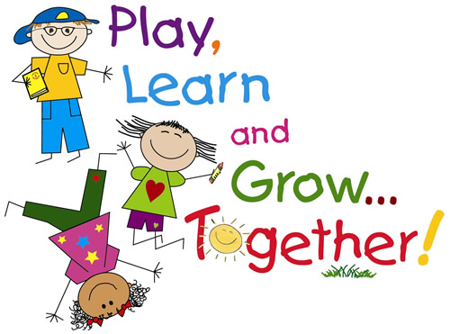**Top Tips for Parents**

**Preparing Your Child for School**

**Independence and Social Skills**

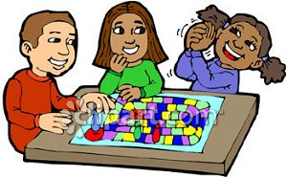It is important that children learn socialisation skills at home as well as school. Ways in which you can help your child prepare is by encouraging them, modelling for them and showing them how to do a variety of basic social skills e.g.

* Using the toilet
* Washing their hands
* Blowing their own nose
* How to use a knife and fork
* Using scissors safely
* Knowing what their home address is
* Knowing colours and shapes
* Fastening their own coats and shoes
* How to take turns
* Saying please and thank-you

**Talking and Listening Skills**

Children make sense of the world by talking aloud with other children and adults, working out the problems they find, and listening to answers to the questions they ask. Talking and discussing helps your child to work things out and communicate.

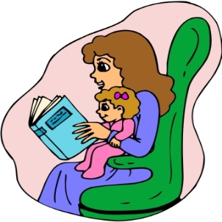

* How to follow instructions
* Tell or read stories
* Listening to audio stories
* Talk about everyday activities i.e. shopping lists
* Encourage them to make eye contact when listening

**Reading and Writing Skills**

Take time to share a book with your child every day. Children enjoy reading different kinds of books. It’s a good idea to visit your local library. Give your child paper and crayons and let them experiment making marks on the page.

**Look Around for Words**

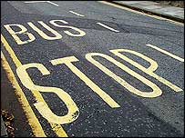Words are everywhere. They can be seen on packets and tins, in magazines and newspapers, on street signs and shops, on posters and advertisements. By drawing children’s attention to words you will be amazed at how quickly they begin to recognise them.

Talk about words you see when you are outside. Often the first word that children recognise is their own name. Help your child to look for words that begin with the same first letter. Choose a letter and see how many words you can find that day which begin the same way.

**h**

= **h**einz, **h**ospital, **h**otel, **h**oover

Learning the sounds of the letters of the alphabet is an ideal way to help prepare your child for reading and writing. This will help your child to understand that words are made of letters and that each letter has a name and a sound.

**Some Suggestions**

* Play ‘I spy something beginning with…’
* Use magnetic letters to make their name and discuss their

sounds

* Make letters with play dough, in sand, with paint or on a

chalkboard

* Encourage your child to use magnetic letters to match words in books
* Make an alphabet scrapbook with letters and pictures
* Share books and model reading to your child

All these suggestions will build confidence and encourage enthusiasm for reading and writing.

**Numeracy Skills**

Maths is all around us in our daily life so try to help your child see it in everything. Developing the language of mathematics is important to help your child’s understanding.

**how many?**

**sort**

**less than**

**share**

**match**

**add**

**more than**

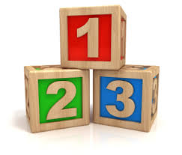**Some Suggestions**

* Use everyday situations to get your child to sort and match e.g. pair socks in the laundry basket, find all the ten pence pieces in a purse
* Talk about items being the ‘same’ and ‘different’
* Talking about things being ‘small’ and ‘big’ or ‘long’ and ‘short’ develops a concept of size and quantity
* Play games to help identify shapes e.g. ‘I spy something square shaped’
* Sing rhymes and songs involving number e.g. Ten Green Bottles, Five Little Ducks or 1, 2, 3, 4, 5 Once I Caught a Fish Alive.
* Make a line of concrete items such as buttons. Hold your child’s finger as each item is touched and count with your child
* Bring number into the child’s home routine e.g. ‘How many spoons will we need for dinner?’, ‘What number is on the door of our house?’ or ‘How many steps to climb to bed?’
* Play games which involve dice and moving counters
* Look out for written numbers on houses, birthday cards, price tags, car number plates, signposts etc.

***Try to make learning fun and don’t forget to praise your child!***