Summary of Reporting, Recording and Monitoring Procedures

St Catherine’s Primary School
Child Protection
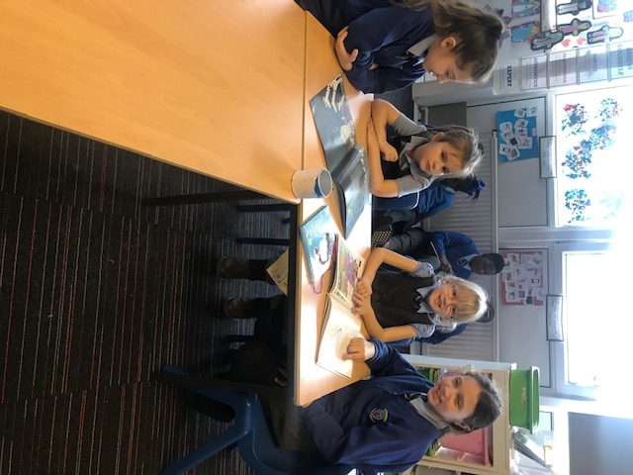

CHILD SAFETY/CHILD PROTECTION POLICY
All educational establishments and services must take positive steps to help children protect themselves by having in place a curriculum that ensures that children have a clear understanding of the difference between appropriate and inappropriate behaviour on the part of another person, no matter who.

Schools, establishments and services must create and maintain a positive ethos and climate which actively promotes child welfare and a safe environment by:
• Ensuring that children are respected and listened to
• Ensuring that programmes of health and personal safety are central to the curriculum
• Ensuring that all staff and visitors working within our school are aware of child protection issues and procedures
• Establishing and maintaining close working relationships and arrangements with all other agencies to make sure that professionals collaborate effectively in protecting children

Should any member of staff have concerns regarding the welfare or safety of any child they must report these concerns to the head of establishment, or the person deputising for the head, after judging that there may be grounds for concern regarding the welfare or safety of any pupil must then immediately advise the duty senior social worker at the local social work services area office of the circumstances.

Management Circular No. 57 – Child Protection guidelines
Summary of Reporting, Recording and Monitoring Procedures: Public Display
A concern prompted by any of the following should be reported in accordance with the stated procedures outlined below:
• a specific incident;
• a disclosure made by a child or parent/carer;
• information from a third party;
• adult behaviours/circumstances that may place the child at risk of harm;
• child behaviours/circumstances that may place the child at risk of harm;
• a culmination of minor concerns over a period of time.

The ASL Section will monitor all referrals and provide termly reports to the Department Child Protection Group. The reports will also inform returns
to the Child Protection Committee.

