
Effective Communication

Our main platform for communicating with our families is through our school website:

www.st-catherines-pri.glasgow.sch.uk

We also use the Learning App Seesaw. This can be downloaded for Apple and Android devices. We are in the process of setting up Microsoft Teams for Live Meets. We will give assistance to any parent having difficulty downloading these.

You can also catch up with any news on our school Facebook page or Twitter.

Should you have a question, query or concern please do not hesitate to get in touch. This includes if you are experiencing barriers to accessing digital resources. The number and email address is listed below:

0141 558 8582
headteacher@st-catherines-pri.glasgow.sch.uk

St Catherine’s Primary School
Remote Learning
Charter

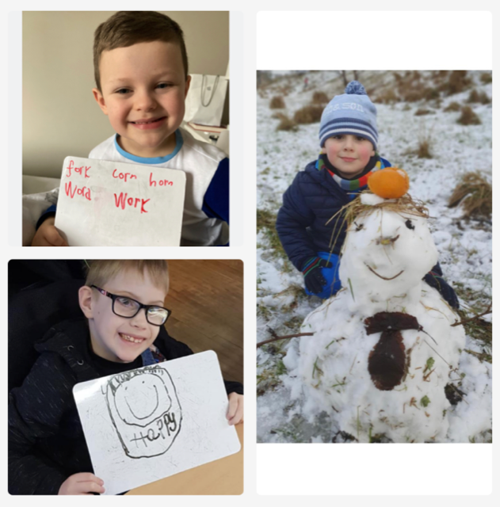
Every child matters,
Every moment counts
What is a Remote Learning Charter?
The purpose of this charter is to support and help children, families and staff to understand remote learning at St Catherine’s Primary during any period of enforced school closure (lockdown) and/or self-isolation periods.

Relationships and Communication:
During any closure (lockdown) or self-isolation period, relationships and the ability to connect with others is important. We want our children to maintain interaction and communication with their peers, to maintain a sense of belonging to St Catherine’s Primary.

Learners are responsible for:
*Checking their Seesaw profile for work posted each day by their teacher.
*Ensuring that they understand the remote learning assigned, and that they ask for clarification or assistance directly from their teacher when necessary.
*Completing assigned remote learning in a timely manner. Not leaving learning to build up until it becomes over whelming.

Parents, Carers an Families can help by:
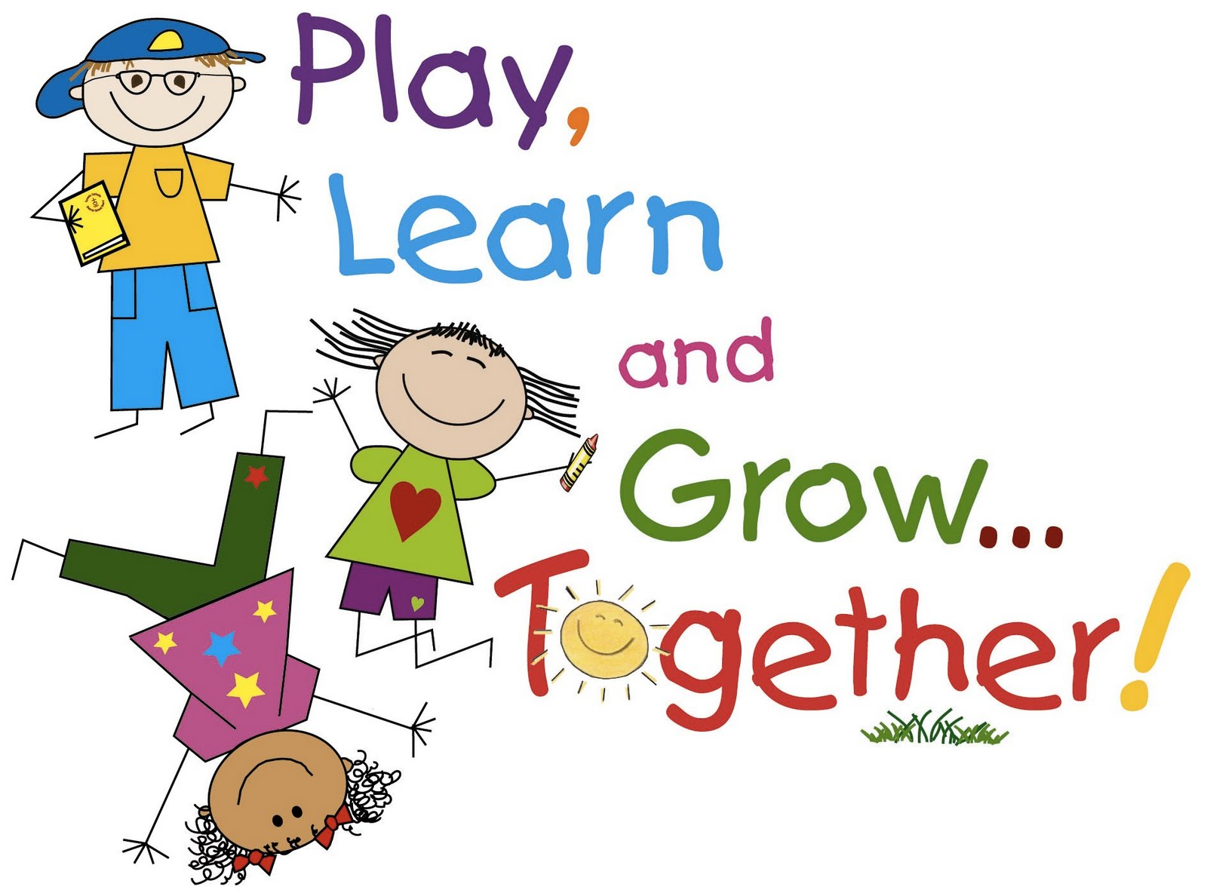
*Providing an appropriate environment for home learning e.g. a comfortable workspace and blocks of uninterrupted time that help support learning. Parents do not need to replicate the classroom at home.

*Giving regular breaks and play.
*Giving praise and encouragement.
*Giving some support especially to children working at Early to First level, P1 to P4, to engage in tasks and communicate with their teacher.
*Having quality over quantity. Focus on what is achievable for your child/ren. There should be a healthy balance between home learning and family time.

When setting Remote Learning our Teachers will:
*Post a weekly grid on a Monday at 9am.
*Post on See-Saw to explain tasks including Learning Intentions and Success Criteria.
*Every day will include a Live Meet, recorded teaching session through voiced over power points, downloaded videos from teaching websites, pre-recorded videos by the teacher and links to websites to watch videos/play games.
*Ensure that remote learning is meaningful and allows all children to develop a range of skills.
*Ensure instructions are clear and allow students a means to ask for clarification, if necessary, through a direct email or message and give feedback when tasks are completed.
*When appropriate, give guidance on suitable websites when setting research home learning.
*Allow opportunities for children to regularly reflect on the learning process itself and their own readiness for learning.

