Peer Mediation
The Peer Mediation scheme allows P1-P3 pupils to try and resolve some of the conflicts in the playground with the help of a P7 mediator who will help both parties in coming to a resolution to the conflict. During Peer Mediation, our P7 Peer Mentors will ask the P1-P3 pupils the 5 key questions to help resolve any playground issues. Peer mediators in the school will only take on small scale conflict and will be supported by teachers throughout the process. Larger scale conflict and conflict between P4-P7 will be dealt with by teachers.

What can you do at home?

Adopt the Restorative Approaches in your home by:
- Asking the five key questions.
- Listening to everyone involved.
- Finding an agreement and a way forward.
- Restoring relationship

Look out for updates on further developments on twitter and in our school newsletters.

St Catherine’s Primary School

The Restorative Approach
Promoting Positive Behaviour

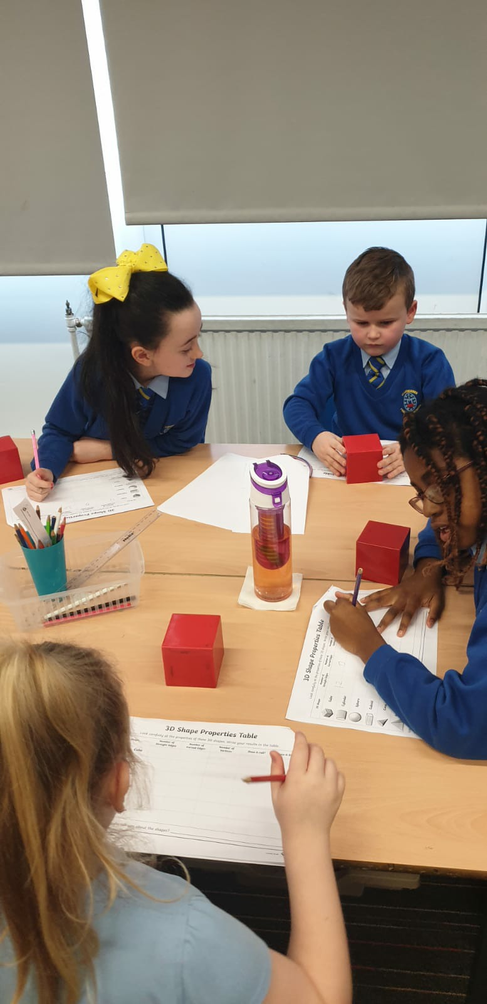

Better Relationships Better Learning Better Behaviour

What is the Restorative Approach?

It is helping those who have been harmed to:
- have their story heard

- be part of deciding what happens next

- have their hurt mended and start again

It enables those who caused harm to be able to:
- take responsibility for their actions

- think about what they did

- understand how their actions have affected other people

- put things right and start again
A Restorative Conversation – the five key questions:

Responding to those harmed:
- What happened?
- What were your thoughts at the time?
- What have your thoughts been since?
- How has this affected you and others?
- What do you think need to happen next?

Responding to those who have caused harm:
- What happened?
- What were you thinking about at the time?
- What have your thoughts been since?
- Who has been affected by what you did and in what way?
- What do you think needs to happen next?

*During Focus Time, we ask pupils the five key questions and give them time to reflect on their behaviour. They then complete a Focus Time exercise based on these five key questions.

