**St Catherine’s Primary School **

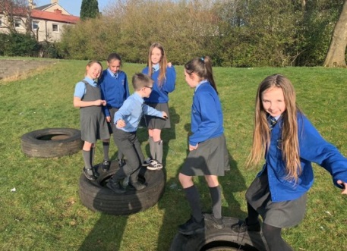

**September Newsletter**

Dear Parents/Carers,

I hope you are settling back into school life as we welcome the shorter Autumn days. The children have been working hard since the start of term and we are very excited for the year ahead.

**Dates for your Diary**

*If parents and carers are invited along to a school event, it will state ‘Parents invited’ next to the event.*

***SEPTEMBER***

2nd – Parents Confirmation meeting 6.00pm

9th – Parent Council meeting 6pm – all parents/ carers welcome

15th – Sacramental commitment Mass – St Catherine’s Laboure Church 11.30am

18th – P4 children to visit the Relics of St Therese of Lisieux

27th – 30th – HOLIDAY WEEKEND – School Closed.

***Safety of our children***  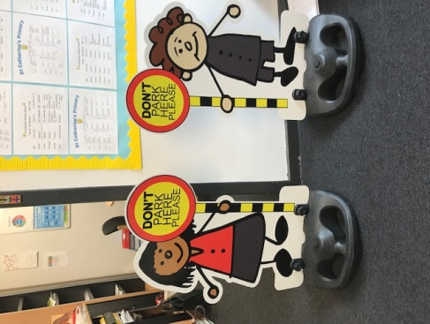

Please look out for news coming your way as we look for ways to improve the collection of children at the end of the day. This will hopefully relieve the congestion at the Senior Exit. In the meantime can I please ask for your co-operation in not blocking this exit.

OUR SCHOOL IS A NO SMOKING AND NO VAPING AREA. Please support us in looking after all our

children’s health .

**Can I also remind you that all parents and carers must only enter the school building through the front door and report in to the reception. This is to comply with our Child Protection Policy.**

**Water **

Water is so important for keeping your child hydrated throughout the day. Please encourage your child to bring their water bottle to school each day with fresh plain water. They can keep their water on their desk and drink it throughout the day.

**Rights Respecting School Award **

We are working towards becoming a Rights Respecting school and renewing our accreditation. Your child will be learning more about Children’s Rights in their classes and we will be looking for ways to share this with you throughout the school year.

**P7 Confirmations **

We are working hard to prepare our P7 children for the Sacrament of Confirmation on the 8th October. The Catechesis dates for the P7s are Saturday 21st & 28th September and Saturday 5th October. These are in the church hall from 10.30 – 12.00. Father Gallagher has asked us to remind children that they should not have their mobile phones out during these classes as this can be very disruptive to the classes.

**Headlice **

Please remember to check your child’s head regularly for Headlice and treat quickly. Your local pharmacy will be able to advise you on appropriate treatments.

**Behaviour towards Staff **

We appreciate all your support as part of our St Catherine’s family. Please remember that all staff have the right to come to and from work in a safe and happy environment. Any concerns or complaints should always be taken to myself or a member of my management team.

*If you wish to contact me about anything in this newsletter please don’t hesitate to get in touch.*

*Best Wishes*,

*Mrs Michelle Wright*

*Headteacher*

*[](http://www.ywcacassclay.org/)****Don’t forget to follow us on twitter for all the latest news and pictures***

[](http://www.google.co.uk/imgres?q=facebook&safe=active&hl=en&biw=1440&bih=731&tbm=isch&tbnid=MpGpuTykj1Ip3M:&imgrefurl=http://www.alvaacademy.clacks.sch.uk/&docid=q3H5bYdE6Tc9bM&imgurl=http://www.alvaacademy.clacks.sch.uk/images/FacebookLogo.png&w=1788&h=594&ei=FKipUtaAOsGjhgfvjoCABA&zoom=1&ved=1t:3588,r:21,s:0,i:156)***- @stcatherinespri - St Catherine’s Primary School Glasgow***